|  |  |
| --- | --- |
| Name |  |
| Qualification | Pearson BTEC Level 3 Extended Diploma in Computing |
| Unit | Unit 15 Website Development |
| Learning Aims | B: Design a website to meet client requirements |
| Title | Design a website |

|  |  |  |
| --- | --- | --- |
| Unit/Criteria |  | Page Ref |
| 15/B.P2 | Produce designs for a website that meets client requirements |  |
| 15/B.P3 | Review the website design proposals with others to identify and inform improvements |  |
| 15/B.M2 | Justify the design decisions, explaining how they will meet the user’s needs and be fit for purpose |  |

**15/B.P2**

**Produce designs for a website that meet client requirements**

**Problem Definition Statement**

**Intended audience**

The intended audience for the website is people who have completed training courses or qualifications related to web development and are now looking for a job as a web developer. The age range of this audience is going to be mainly young adults who will be knowledgeable on websites so it better be good otherwise it would make the company look bad.

**Full summary of the problem to be solved**

I will have to create a new section for the company’s web site that promotes the company to prospective employees, as they need to recruit more web developers.

I will need to produce a website and include these topics on it:

* a profile of the company itself
* profiles of existing trainee web developers
* job specifications and required qualifications
* an on-line application form
* links to web development courses

The website will need to be appealing to the target audience and allow ease of use for people looking for a specific function on the website and to not prioritise unnecessary things that would get in the way.

**Constraints**

Developing this website I will have several constraints.

* Time – There is very limited time so the website must be developed quickly and efficiently including the documentation.
* Knowledge – I don’t know much about web development so this would constraint the website from being able to show its full potential as the developer doesn’t know how.
* Money – The amount I am paid determines how hard I work so paying less will mean that the website would have less development time and therefore it would be a simple website.

**Benefits**

The benefits from developing this website.

* Hot Beans Web will be able to find new employees by advertising the job positions on their public website.
* There will be web developers being employed because they found a job using the website.
* Hot Beans Web will make more money if they have more developers working as they can produce websites faster than before.

**Nature of Interactivity**

The website will only have simple interactive elements such as the job application form. The website doesn’t really require much interactivity as it would be mainly information displayed with the jobs.

**Complexity of the Website**

The website will be a simple website. All that the client requires is some information to be displayed along with the jobs they have available. This may only require two or three pages to complete so this shows the project will not require a large team of developers.

**Purpose Requirements As Defined In the Client Brief**

The company is wanting to create a new section for their web site that promotes them to prospective employees, as they need to recruit more web developers. They want to add the following things on their website:

* a profile of the company itself
* profiles of existing trainee web developers
* job specifications and required qualifications
* an on-line application form
* links to web development courses

The company will require

* One or several new webpages
* A way to apply for a job
* Information to be displayed about themselves and their employees
* Links to courses on web development

**Detailed storyboard design ideas to include design elements from Unit Content B2**

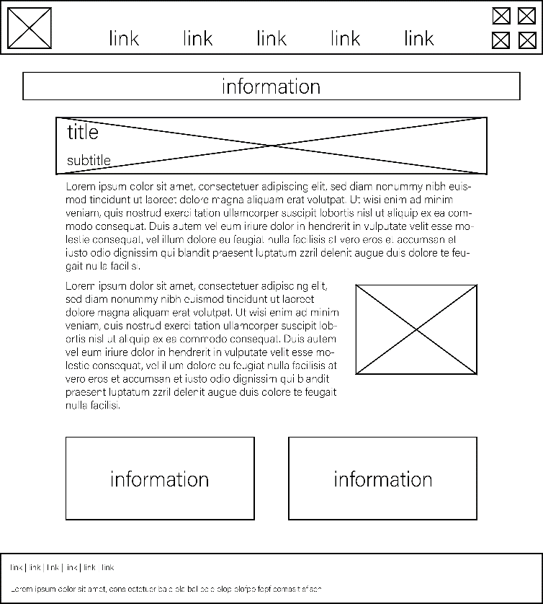**About Page Our Team Page**

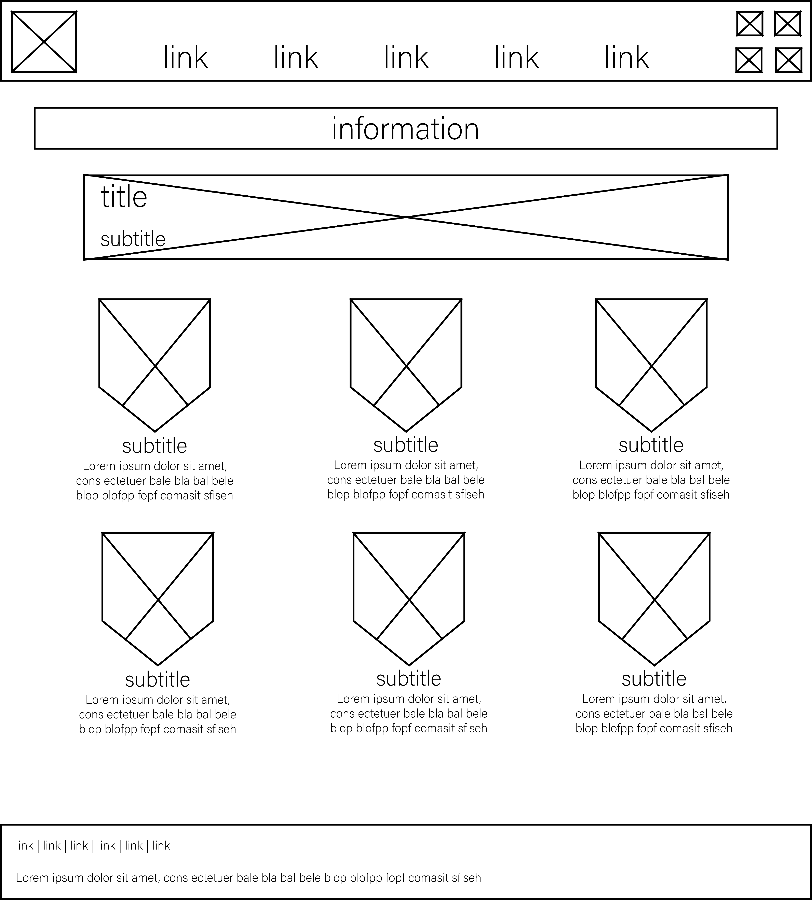

**Jobs Links**

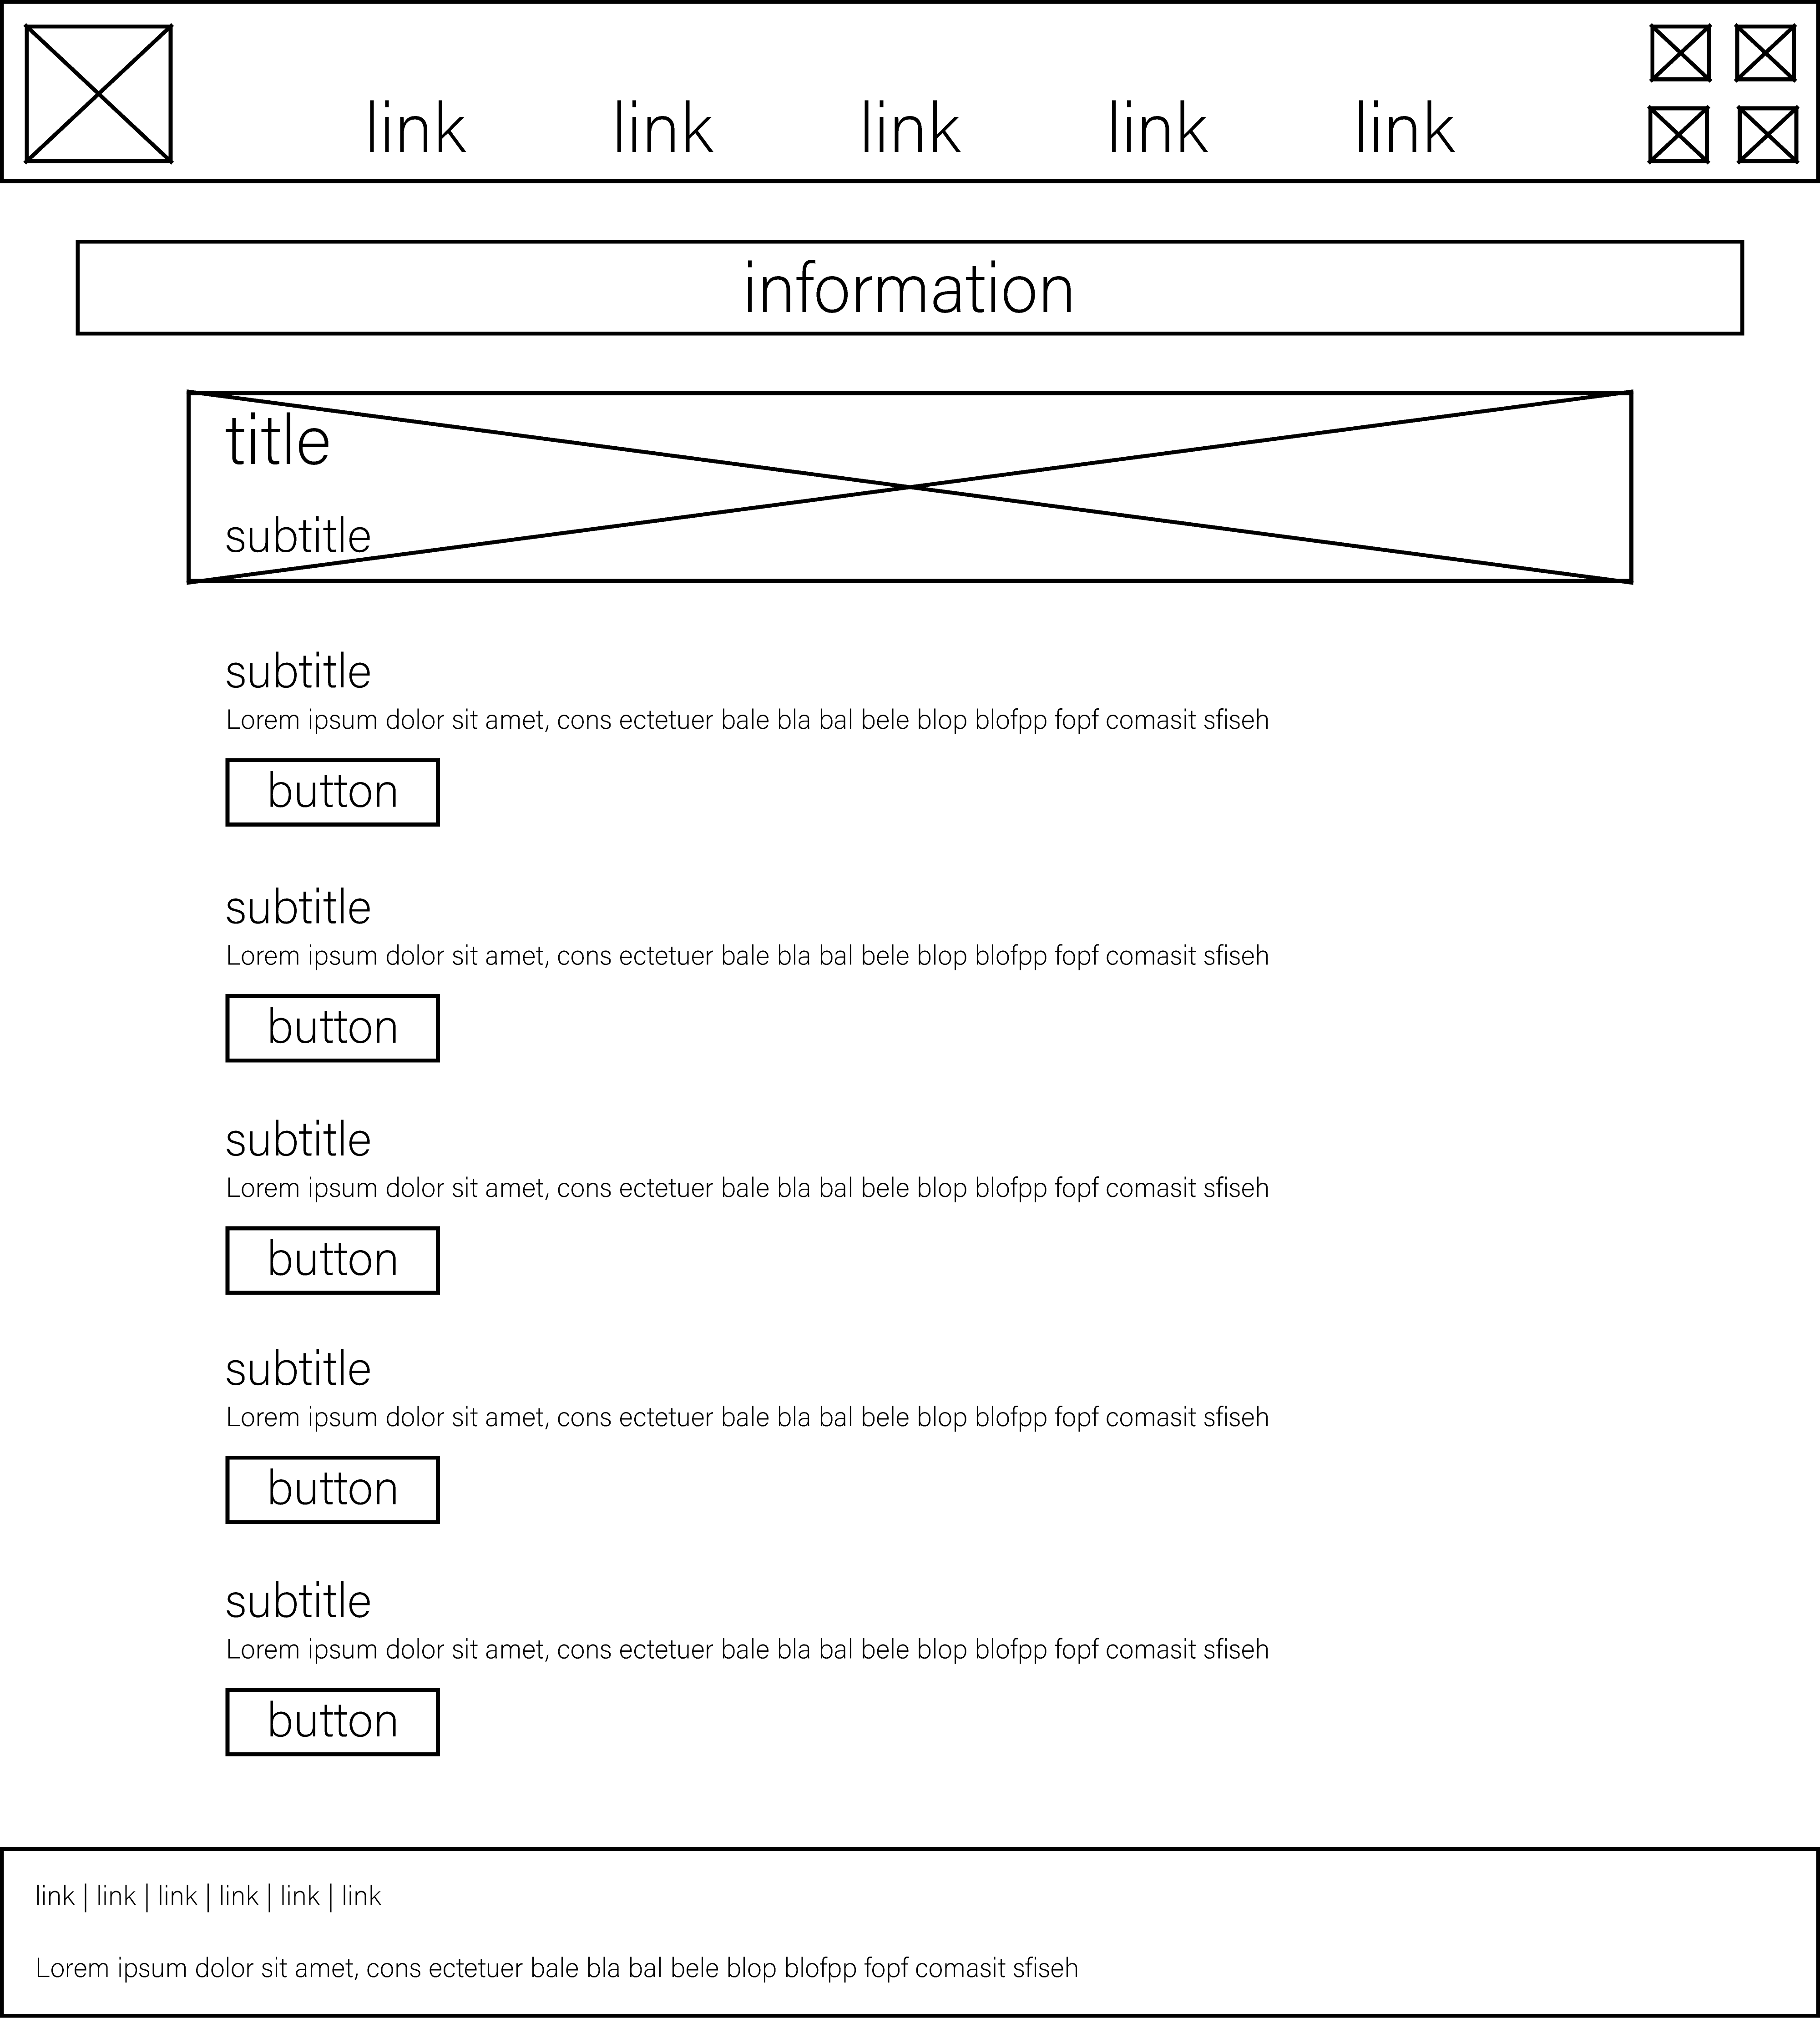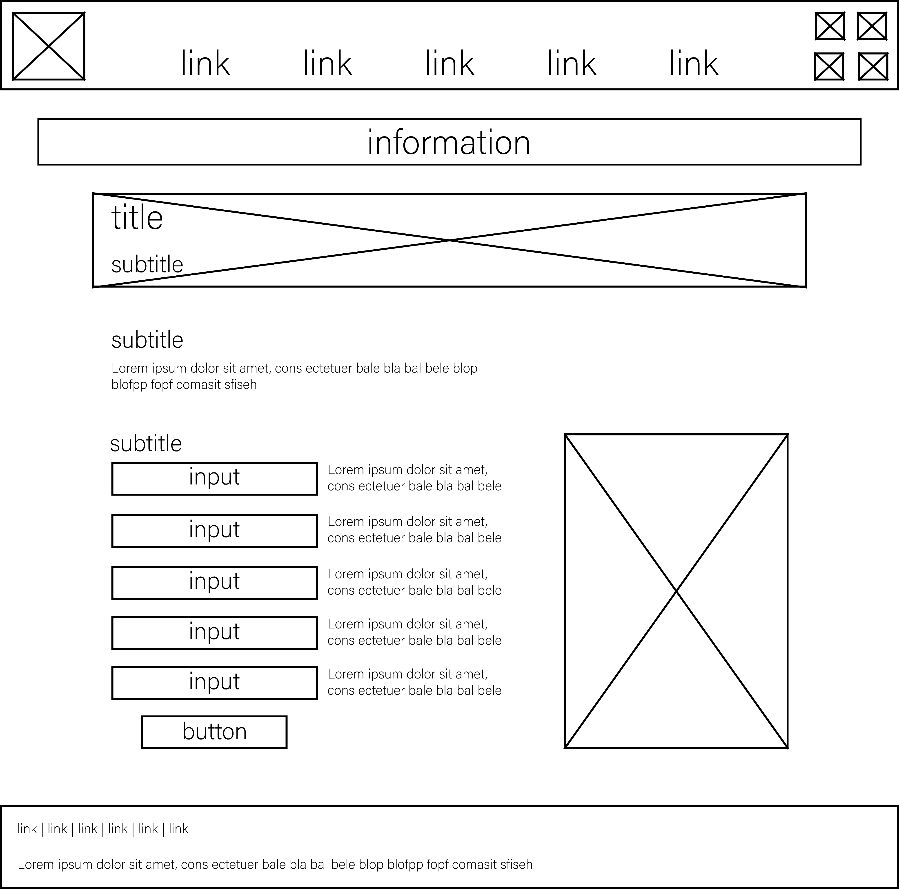

**Alternative design ideas, including mobile/tablet designs**

**Alternative design**

**About Page Our Team Page**

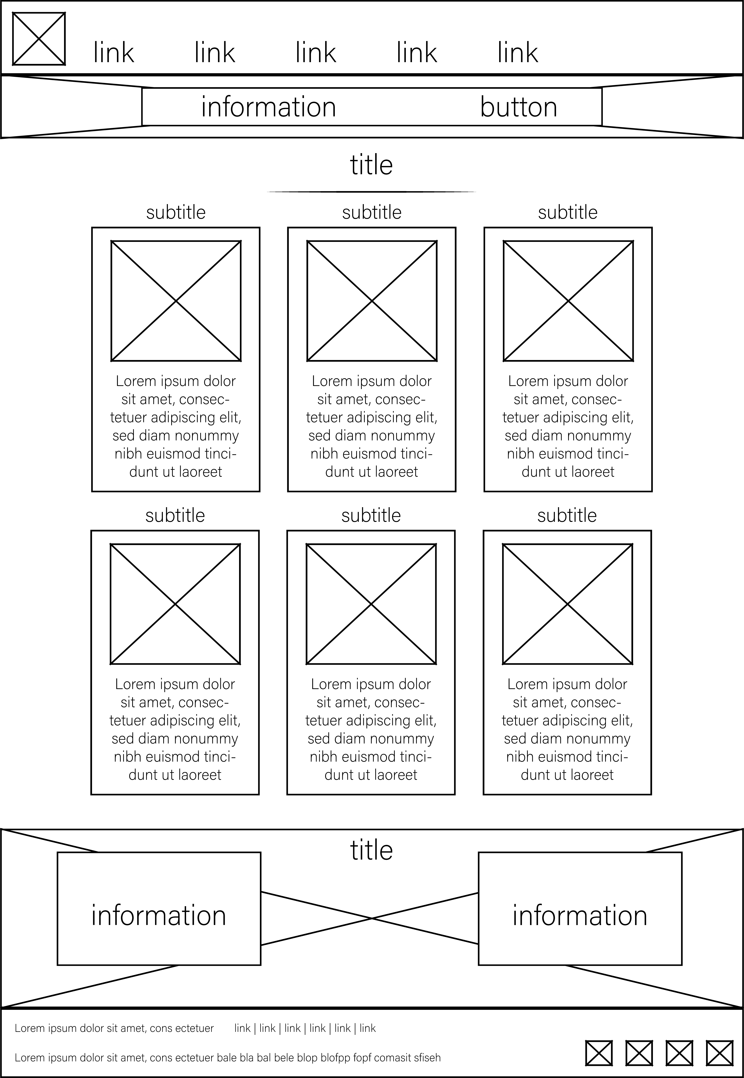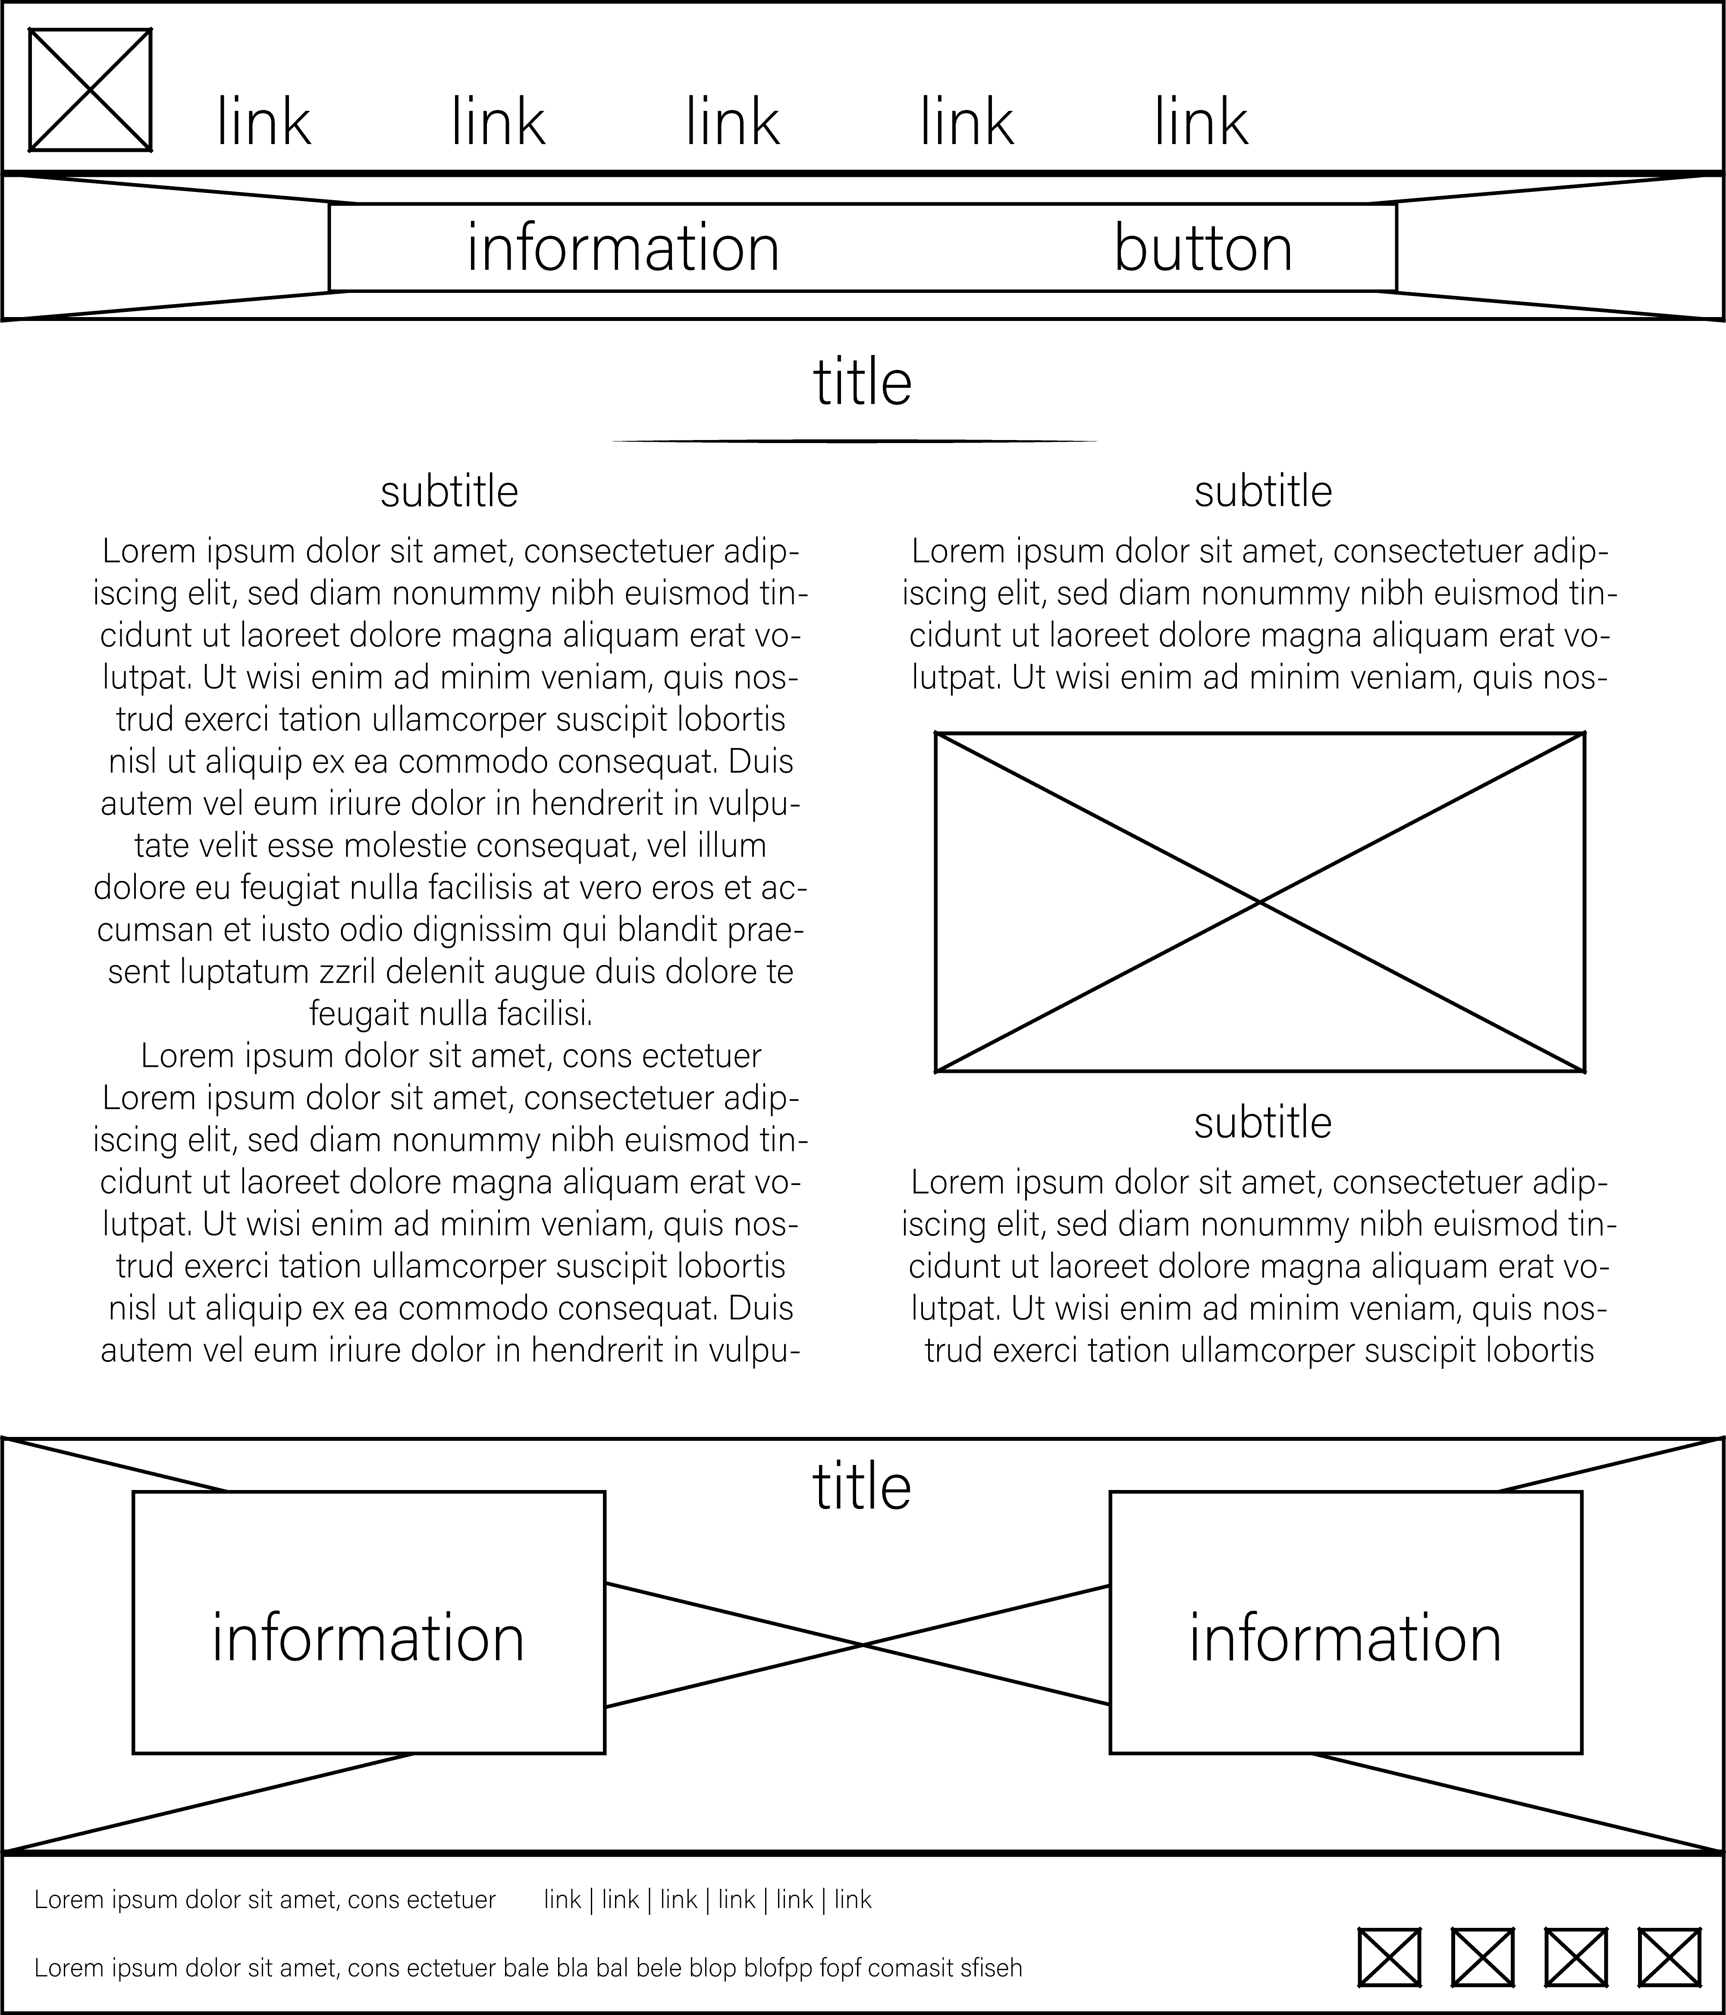

**Jobs Links**

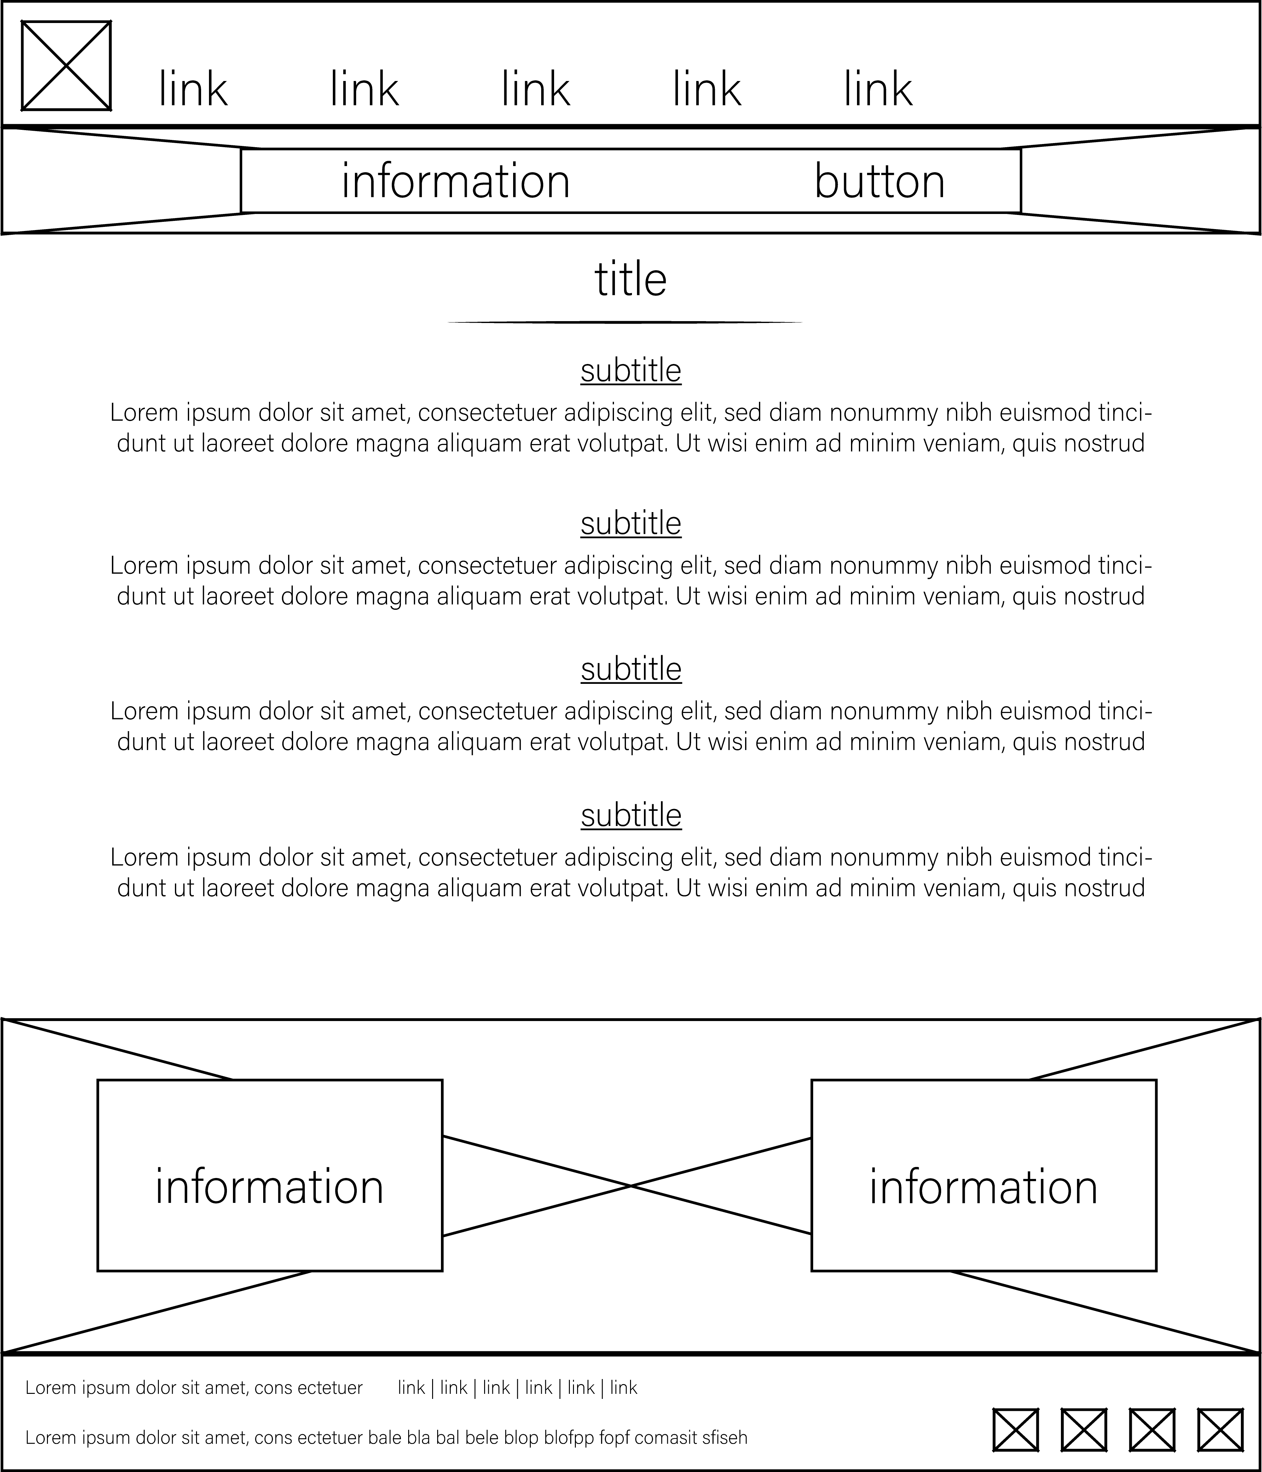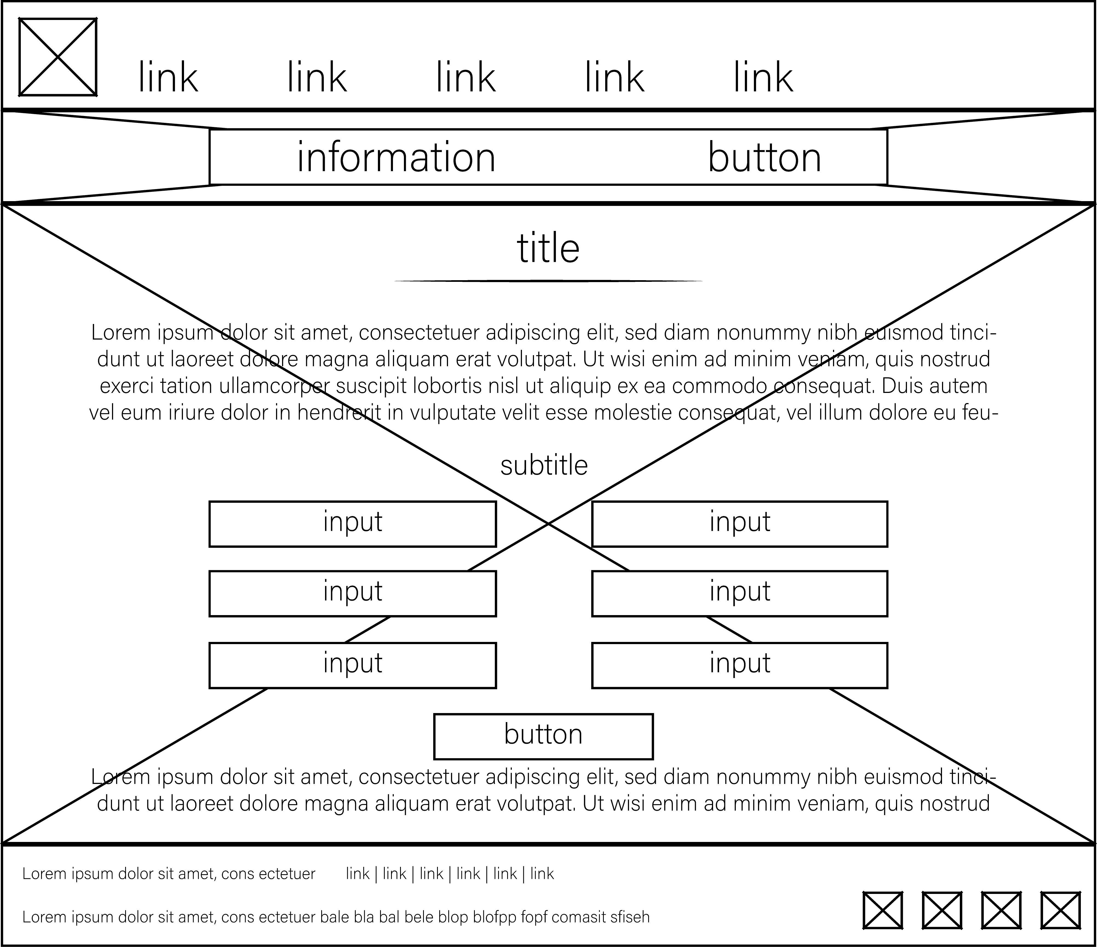

**Mobile Designs**

**About Our Team**

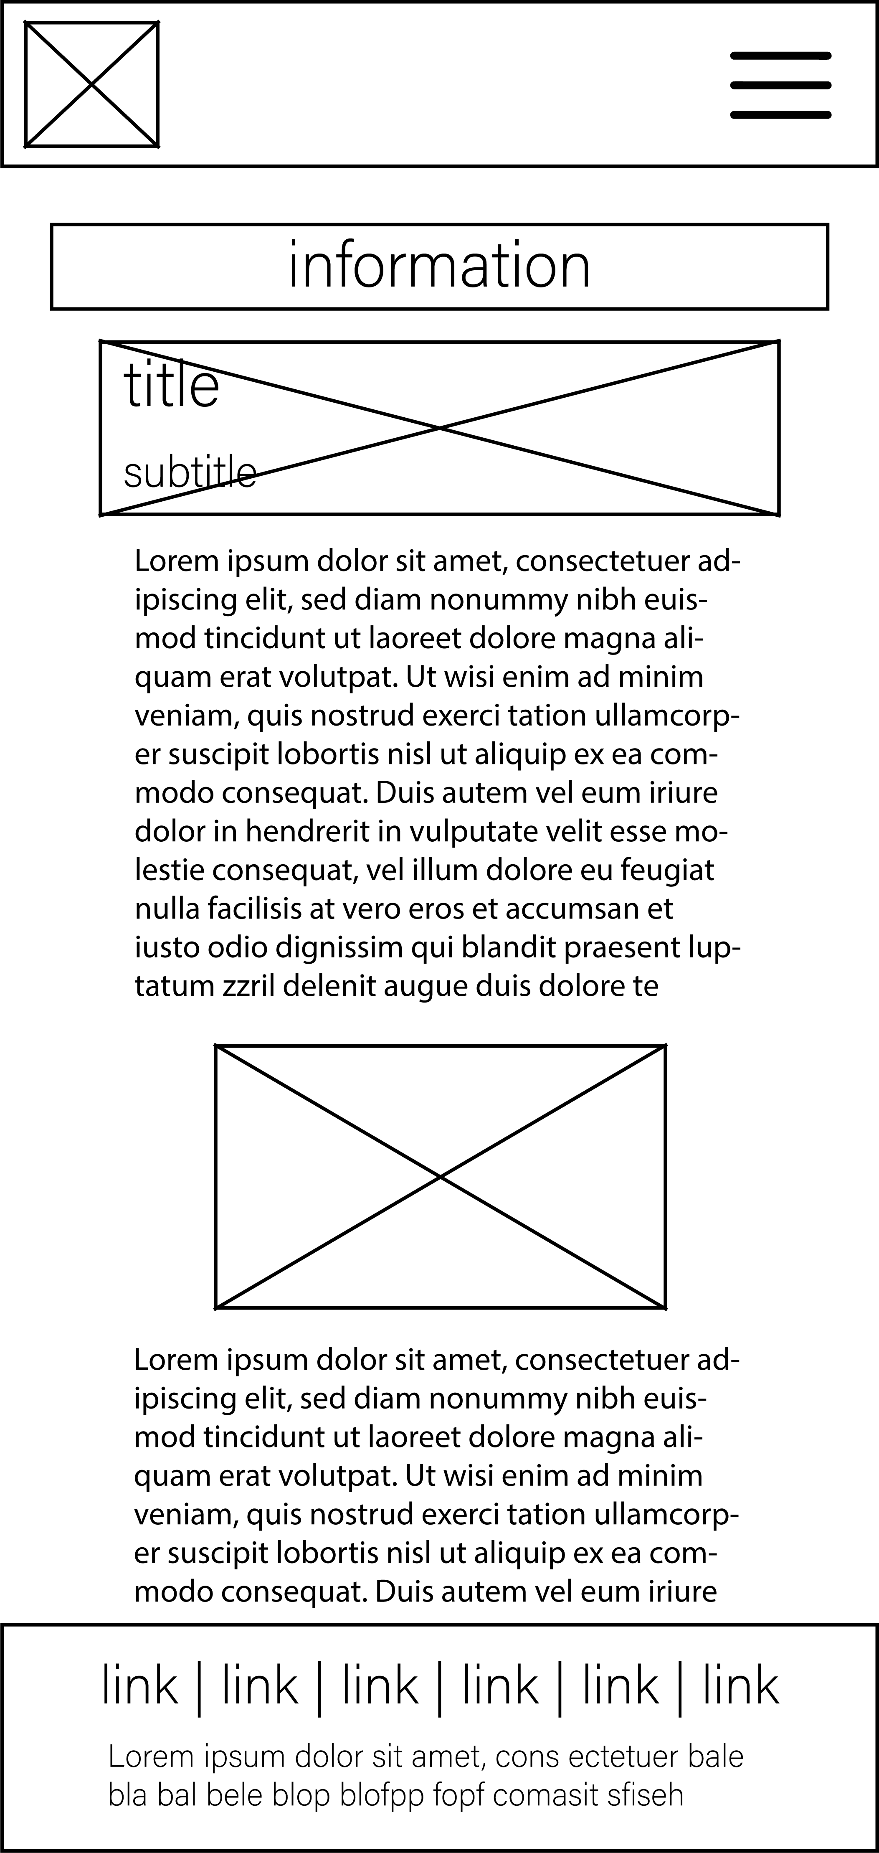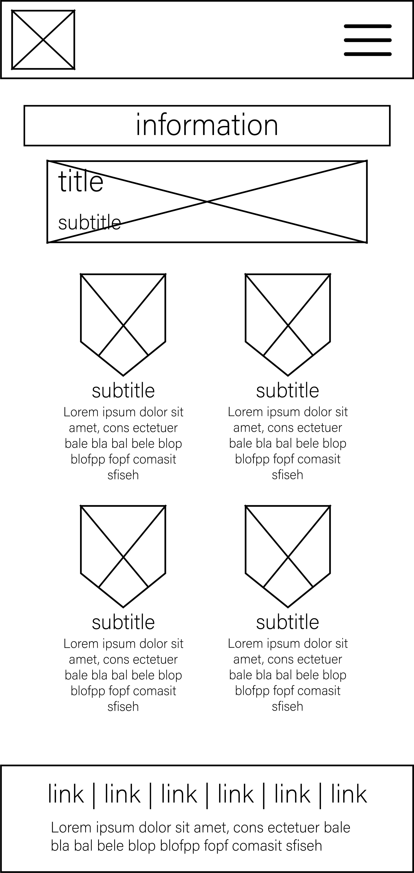

**Jobs Links**

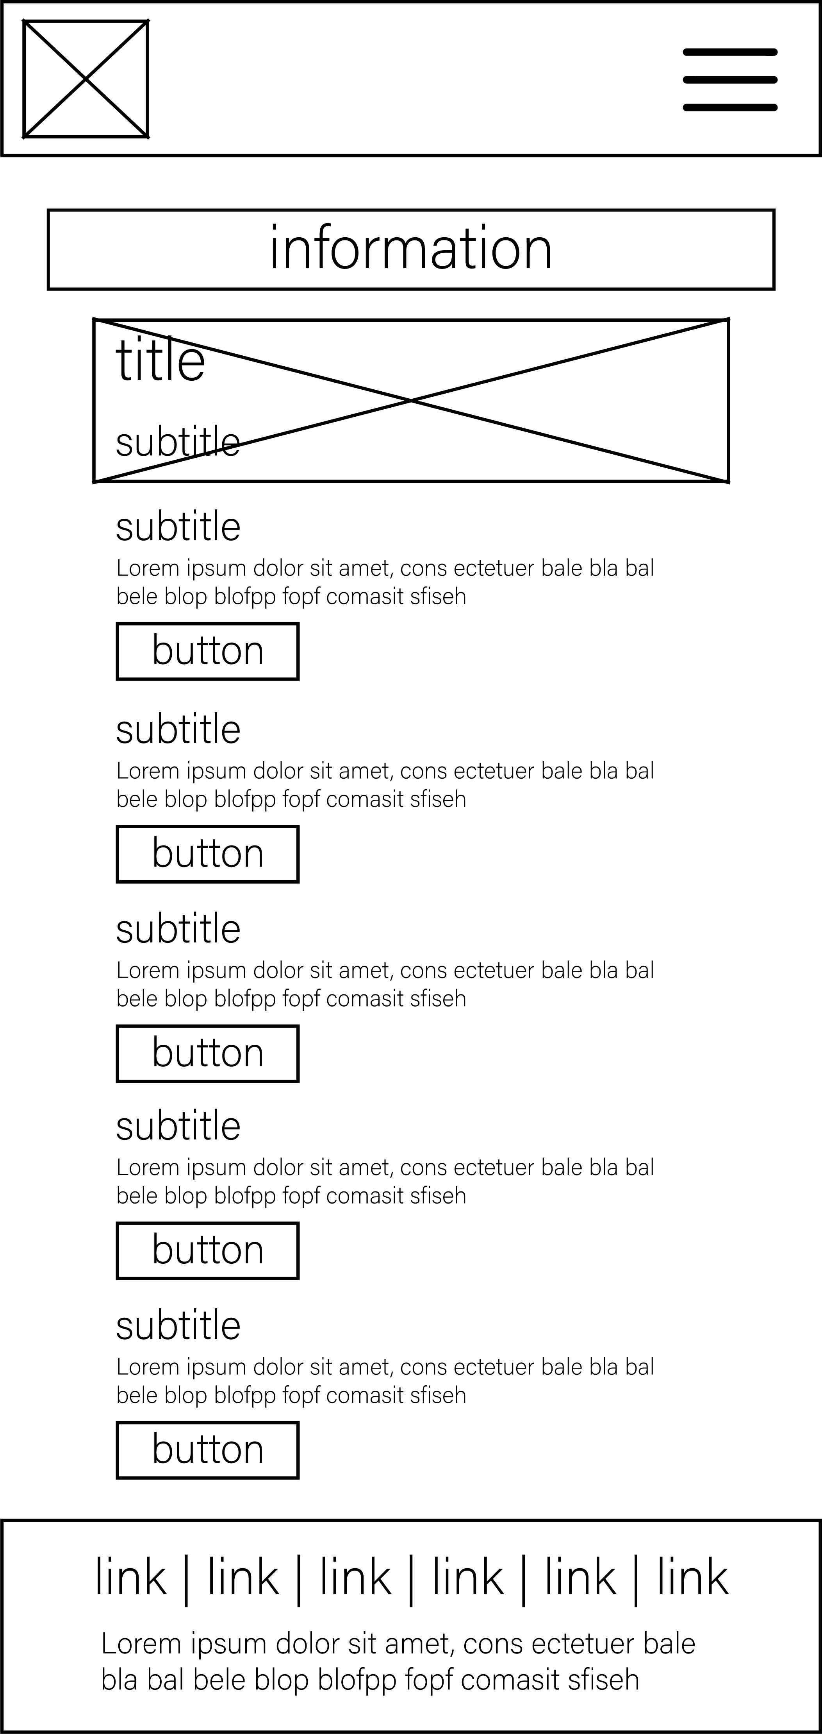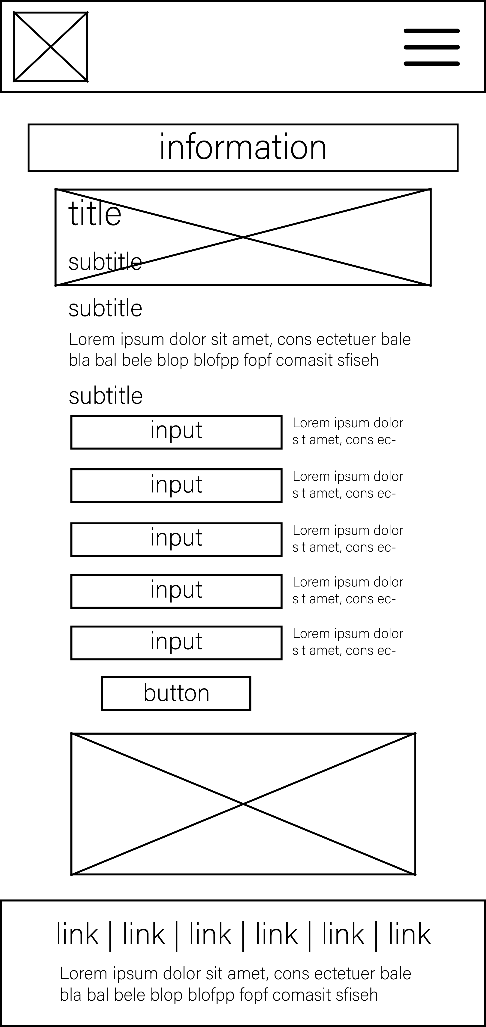

**Client-side scripting design tools and techniques**

The tools you would use to design client-side script for a website are web development IDEs such as Dreamweaver. The techniques are you would think about what it does then translate to code and write it.

**Fully referenced assets list**

Not done yet

**Technical and design constraints and how to work around them**

The design constraints for this are

* The capacity of HTML – some things may not be possible with HTML and CSS and therefore cannot be made into the design. To work around this design constraint we should design it with respect to HTML so the developer would needs to look over designs and tell if it’s possible or not.

**Legal and ethical considerations that are applicable to include Copyright, Designs and Patents Act 1988 and Data Protection Act 1998**

The copyright laws for this will apply to any assets that are used in the website that I have not developed or drew myself. The copyright would be violated if the owner of the copyright refuses reuse commercially on a website. So during development any downloaded assets used in the website, including standalone scripts would need to have their licence or copyright considered while making the website. If I were to use stock images for the website I would have to buy the rights to use it from the provider. Some images may be free, it is all specified on the page it comes from.

**Technical documentation**

* Platform compatibility (browser, operating system, mobile devices)
* Testing tables that outline a variety of tests that will cover:
* Functionality
* Compatibility
* Usability
* Constraints

**15/B.P3**

**Review the website design proposals with others to identify and inform improvements**

**Feedback from test users:**

“I think the first design looks more modern you should use that I like information displayed its useful um maybe improve the jobs section of the alternative design why would it have a picture background that would look terrible, so I think it should have a picture next to the boxes not under.”

“Ok designs are good I would choose the first design as it looks nicer you could improve the bottom bit on the alternative design because it looks weird with that huge box at the bottom”

“Well that looks nice I like the first design for most pages and you should possibly add some more spacing on the first designs about page its really tight even though the design looks all spread out”

**Feedback from company:**

“We are very impressed with these designs and are feeling confident about the success of this website extension. The design we feel needs some more work is the about page for the first design. Just tidy up that design and put the same amount of passion into that as you did the jobs page for the first design because that looks good. One other thing we would like you to reconsider is the header for the alternative design as it feels a bit plain with just some misaligned links on it.”

**Effects from the feedback I received:**

Using the feedback I received from the users I feel that I should use mainly elements and the overall style from the first design in my final website as it’s the most liked style of the designs. I will improve the layout of the about page maybe using some elements from the alterative design. The feedback from the company has made me see that the about page for the first design needs to be improved as the company does not like it. This feedback has been useful in informing me about what I should be improving in my design so that I can improve it and make it all look better.

**Improvements to the designs**

I have improved the about us page and the jobs page for the alternative design.

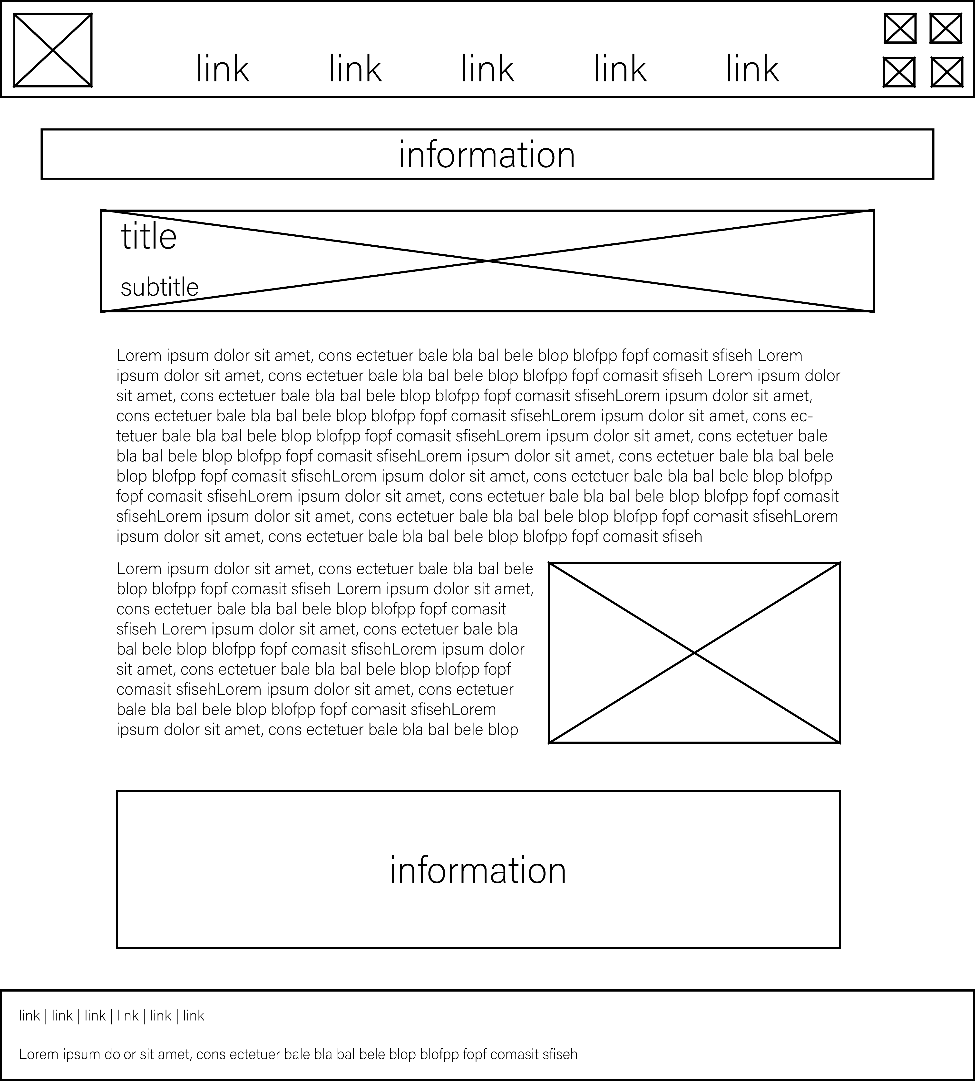

I have improved this design by fixing the spacing in-between the text and adding a large information box under the text.

I have also improved the jobs page in the alternative design.

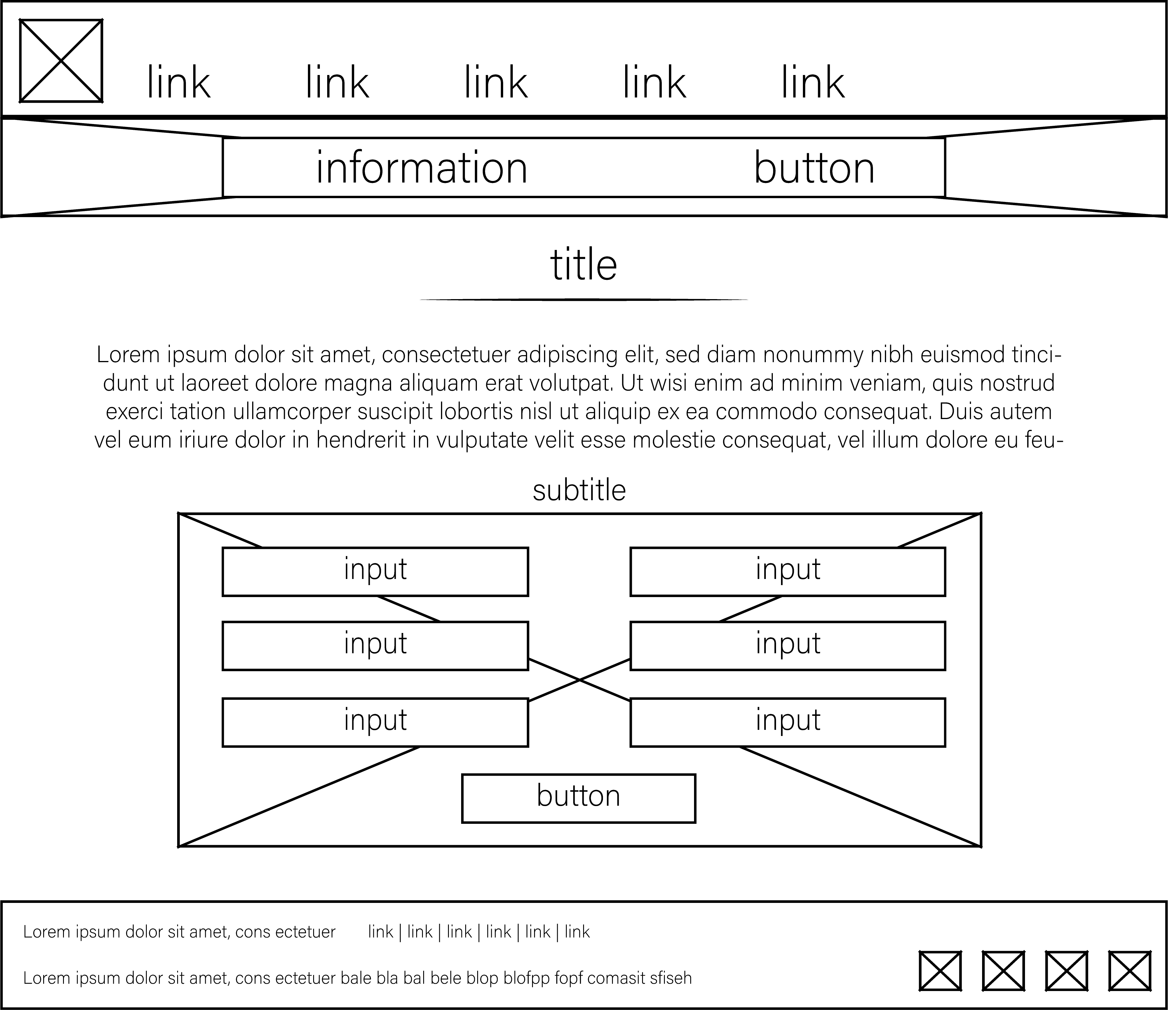

I have improved this design by making the background image only on the form as the form items will be in boxes so the background would be ok but the background on the text does not look good because it would have complex colours and the text would be hard to read on it.

**15/B.M2**

**Justify the design decisions, explaining how they will meet the user’s needs and be fit for purpose**

I have added an information bar at the top of both designs because I wanted the user to be able to see the company’s current information that they want to show the user, such as current jobs which would link to the jobs page. In the about page for the alternative design, I have put the information boxes under the text so the user can see some company statistics and other information. In the first design, the picture at the top with the title on is so that the title and subtitle are separate from the main text. The footer is including only links so that they can click it and go to that page. The header navigation bar is centred so it looks nicer but then the title isn’t which makes it look strange and not consistent but it should still be ok. The user would need to see information about the company including pictures so they can see the company. So I decided to make the picture wrap the text so it could be included wherever they want so it can be seen well. One other thing I did was make use of indentations and made it so the items get thinner as they go down so it makes the other items look even more separate which is better for the user as its easier on the eyes. I have decided to make the pictures on the team page a complex shape because it looks like an arrow pointing down to the text which is not encased in any box so it’s just assumed that it’s linked to the picture. The shape makes it easier for people to know what the text is referring to. I decided to make the links on the links page aligned to the left like the title area which makes the website look more consistent. The links are larger buttons so that it’s easier for the user to know where they should click. The titles and subtitles are clear and have slight whitespace in-between them.

**Comprehensive Designs**

**About Our Team**

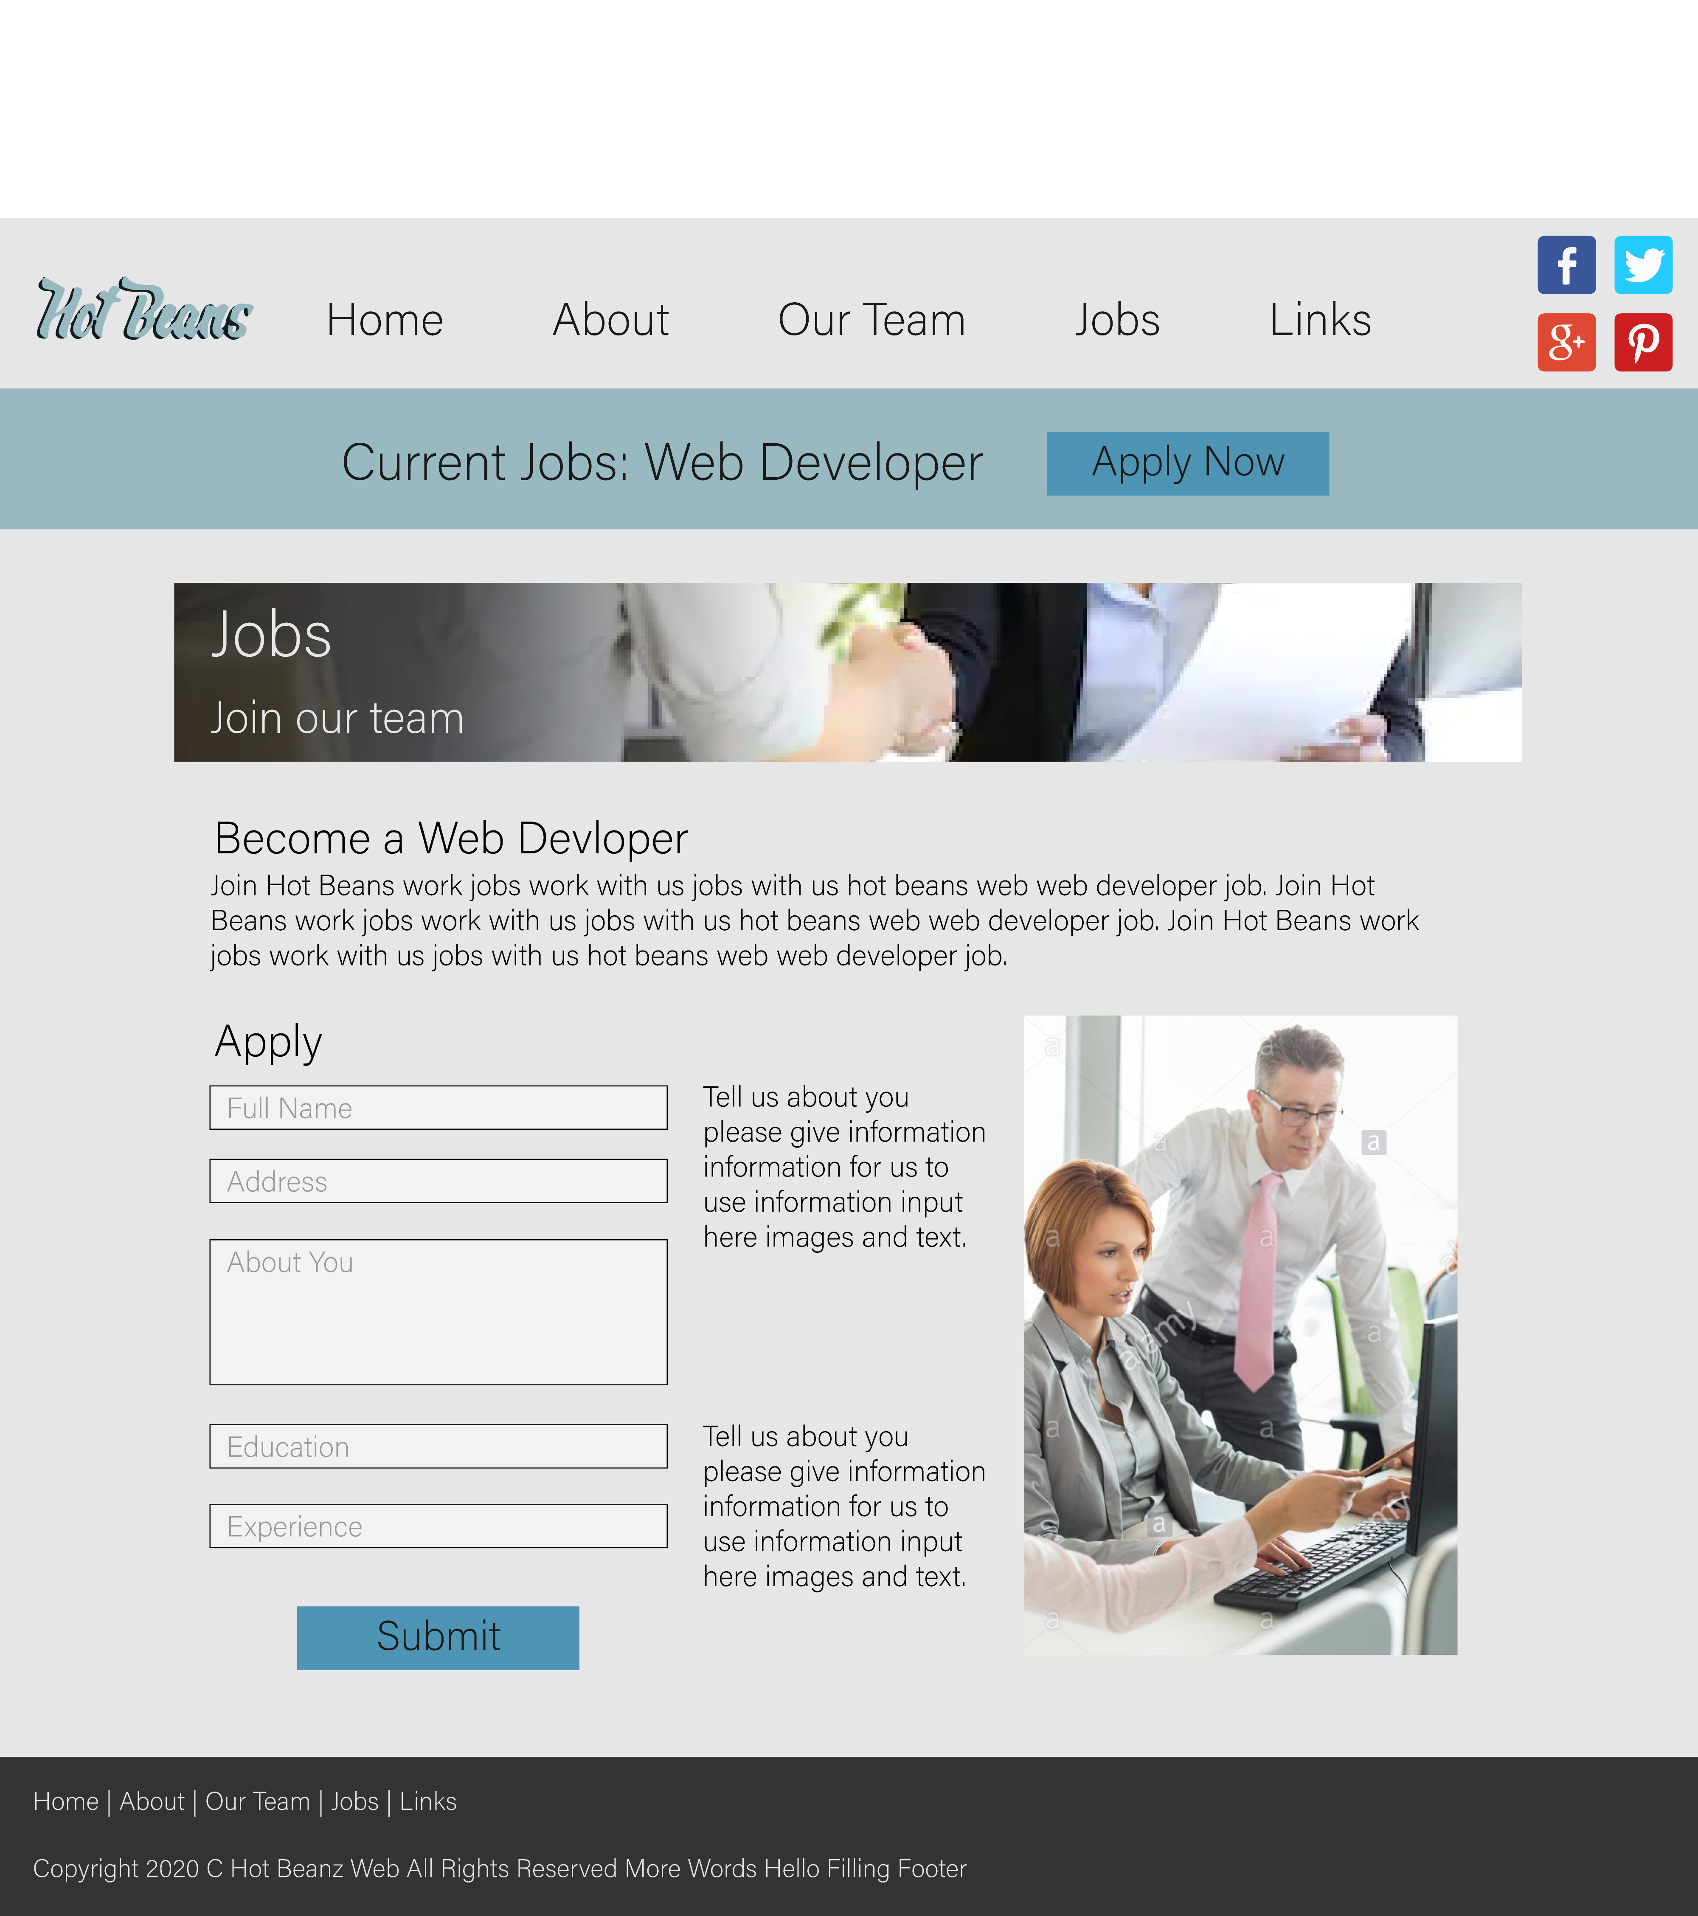

**Jobs Links**

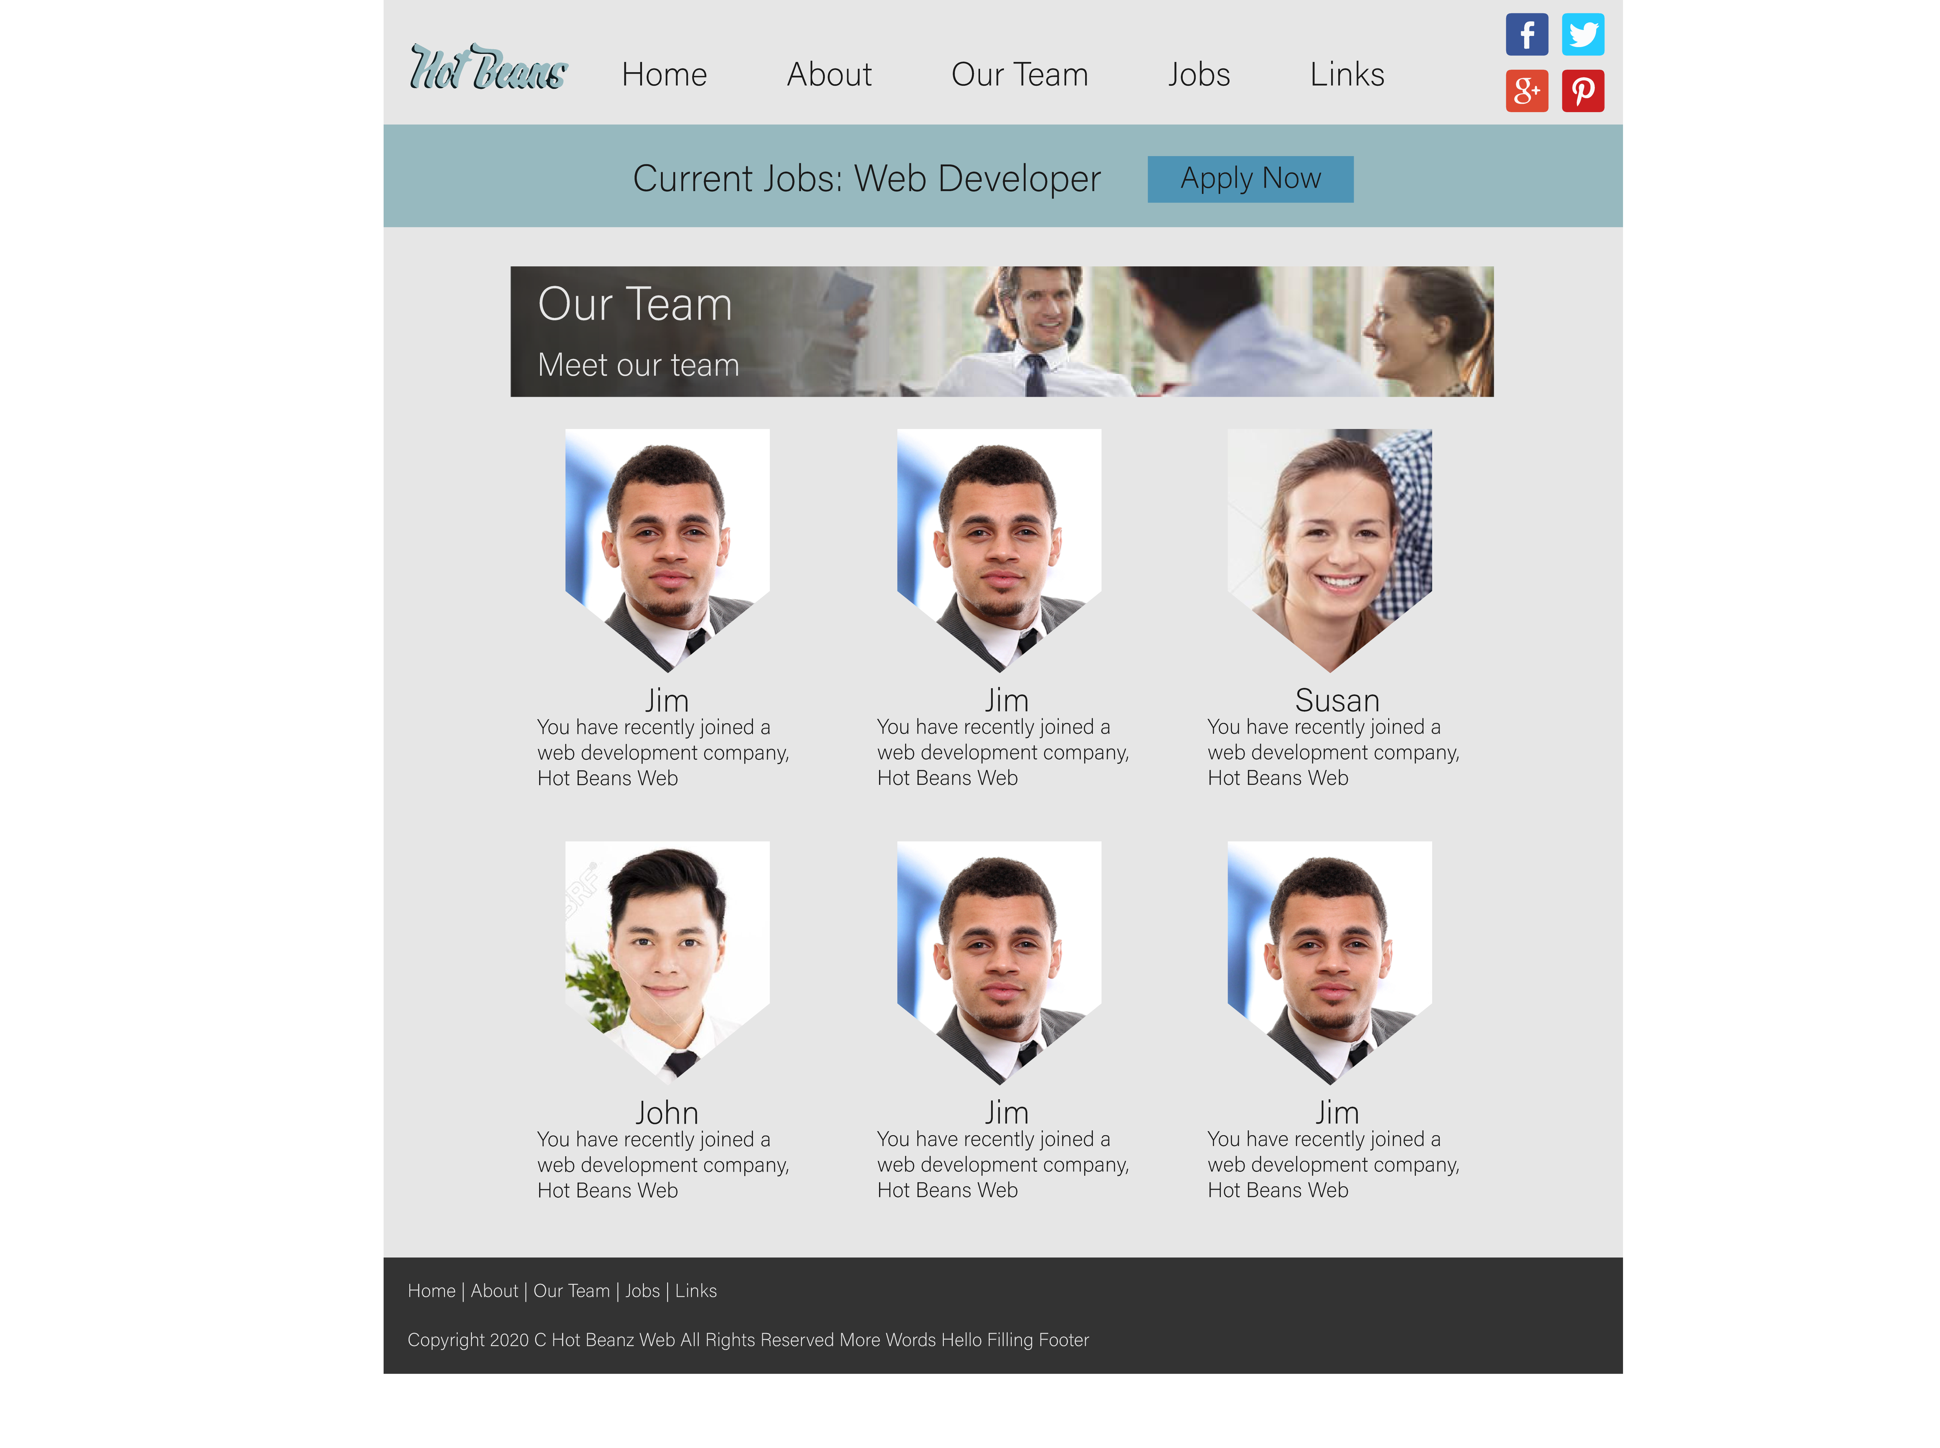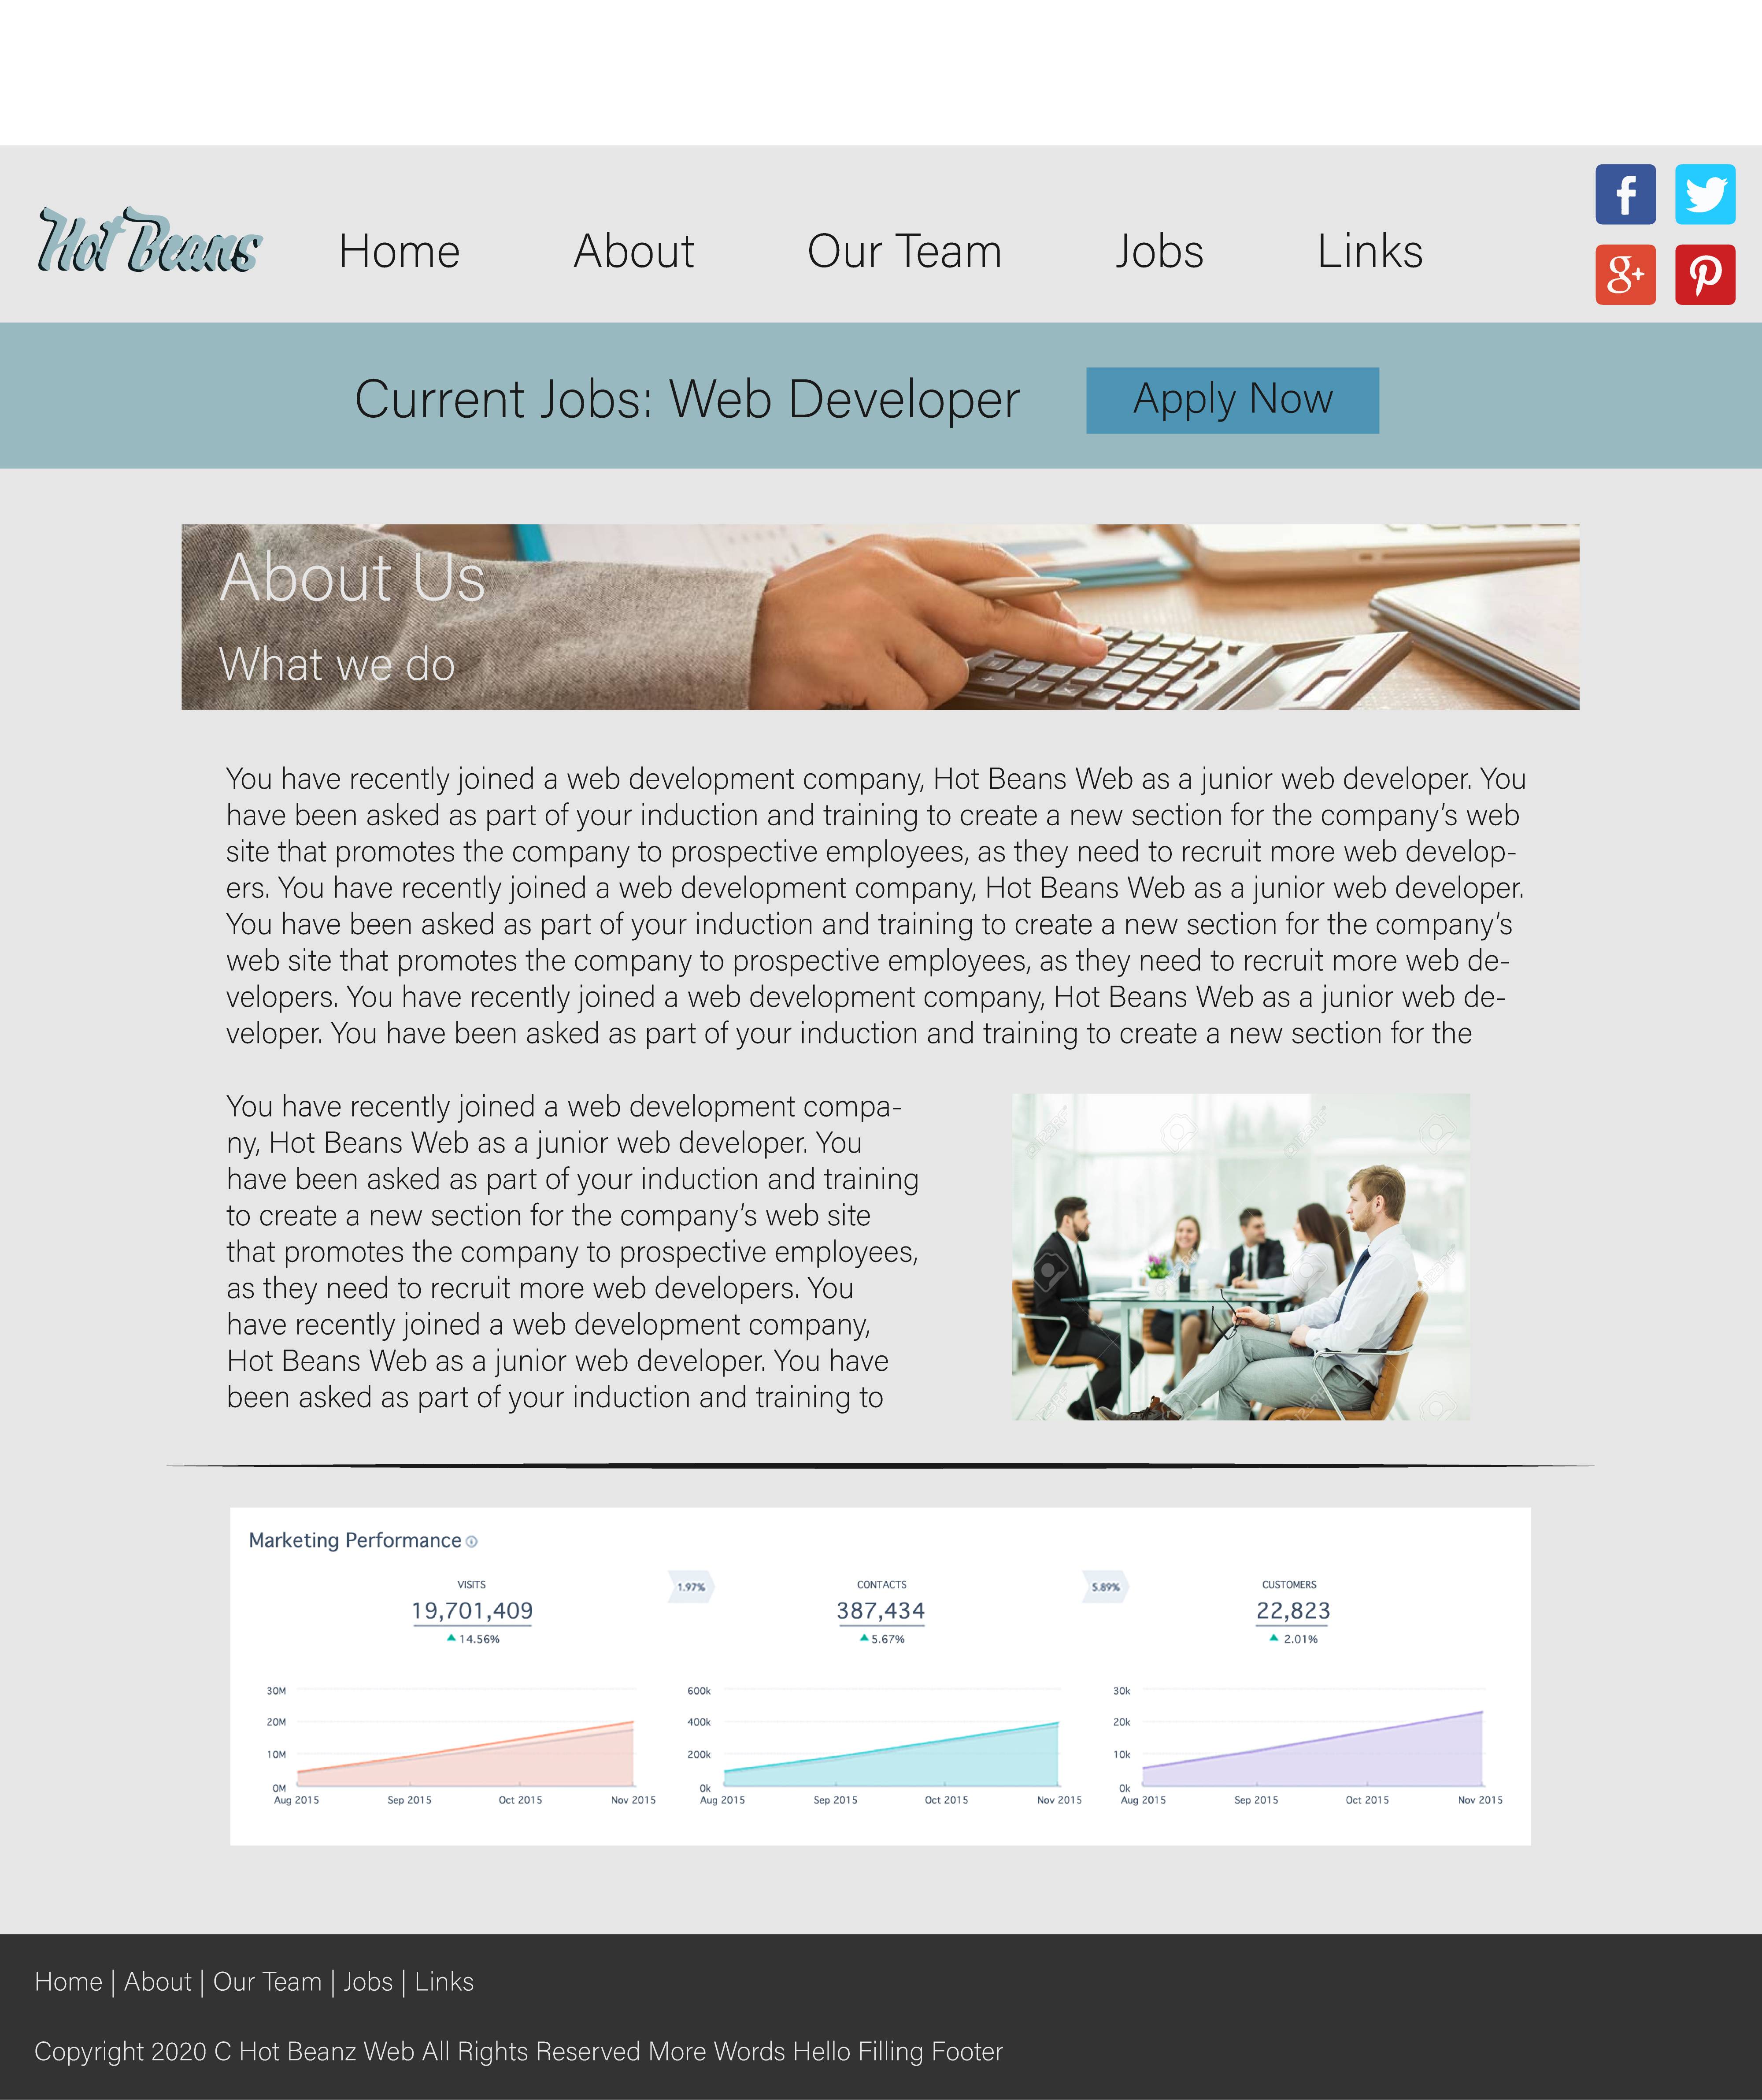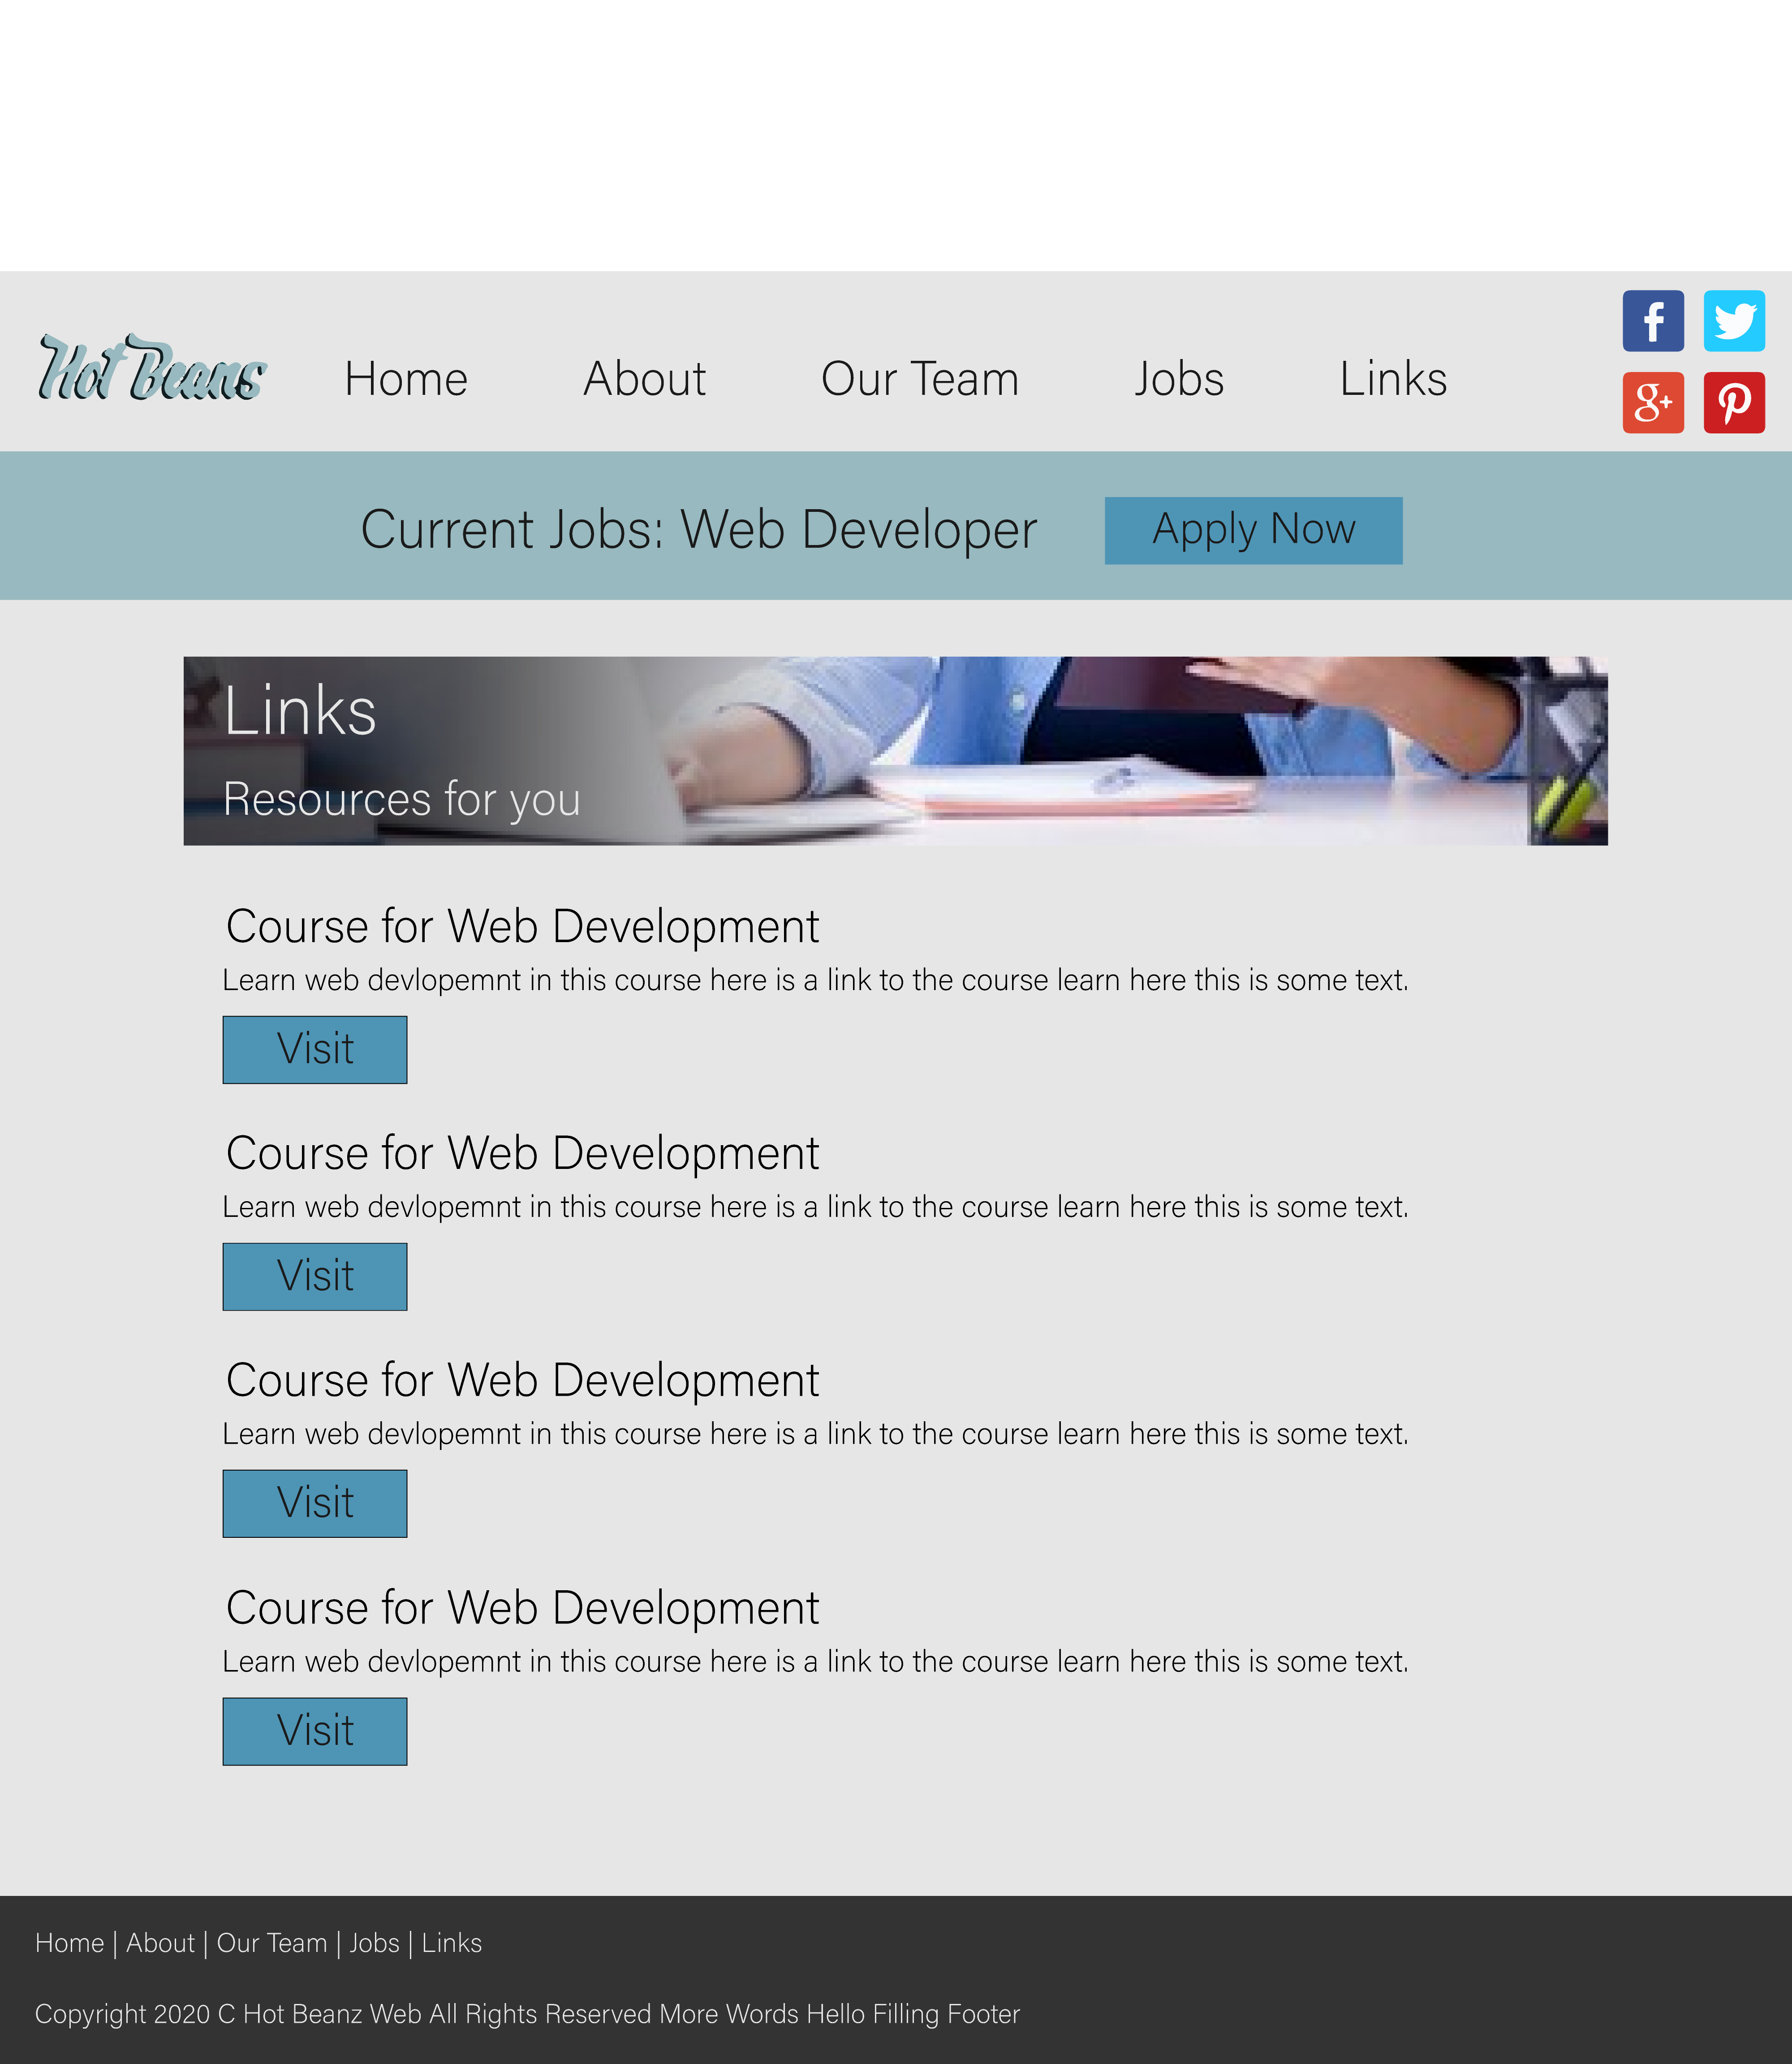

**Feedback for the comprehensive designs:**

“very nice they look professional you should improve that line on the about page it looks ugly and out of place, the colour is too dark and it stands out too much so lighten it or delete it I think”

“Good I like the pictures it feels like a real website. You should think about those button in the links page that’s the only thing that doesn’t feel like a real website it looks too amateur maybe change the buttons or remove them and make the subtitles clickable or something.”

“It’s nice the colour scheme is pretty cool but those social media links really break the colour scheme I’m not sure what you could do maybe make them so their like those white social media links with a cut-out for the logo in it maybe try that those colours look weird on the header there and they are also way too big.”

**Improvements Using the Feedback to Create a Final Design**

**About Us**

I have improved this design using the feedback so I changed the divider line to make it less black and also made it shorter. This makes it less noticeable on the page. Also the feedback had mentioned that the social media links were too bright so I changed them to black circular logos so that they look more modern and also the colours aren’t too over powering. The reason why I changed the divider line is because the users need to just focus on the information and a big black thick line would be too noticeable so I changed the colour and make it thinner.

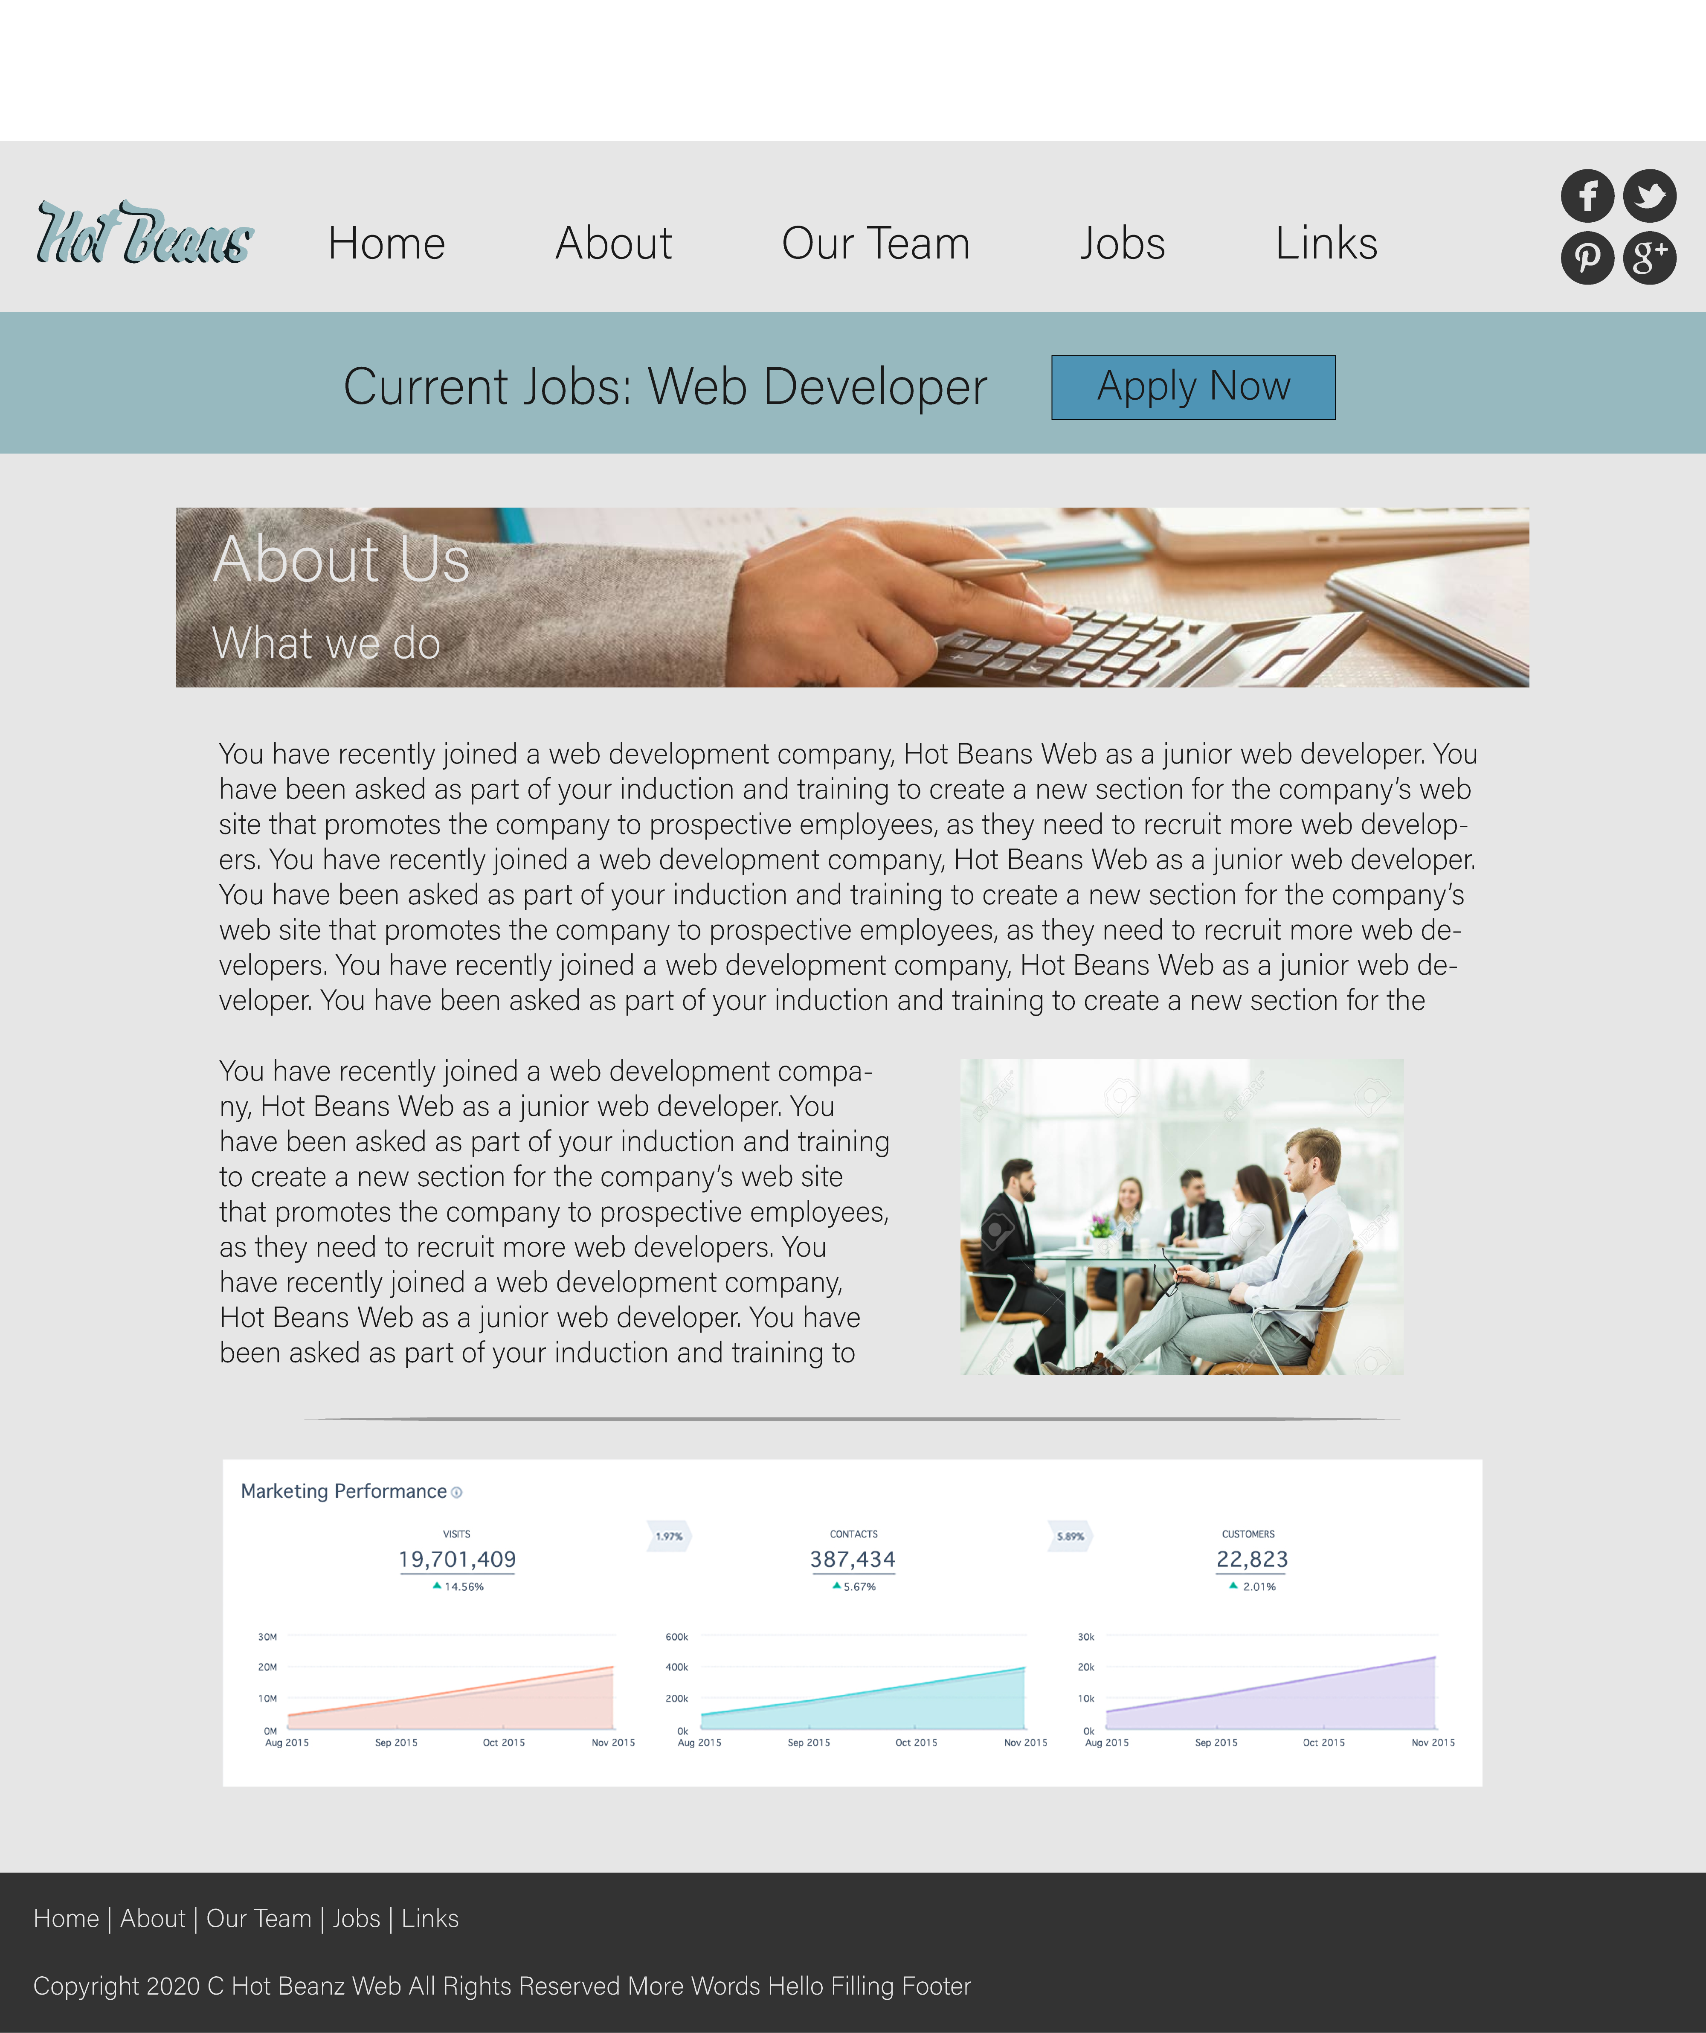

**Links**

I have improved the links page by using the feedback which mentioned that the buttons were too weird in their placement and it felt amateur so I moved the buttons to the side to make the page a bit more compact and to make it look a bit better. I still don’t feel this is perfect so this would probably be adjusted in the final website. The reason why I changed the buttons is because the website would be able to display more links in a smaller space and therefore that would allow the user more links so they will be able to see more links.

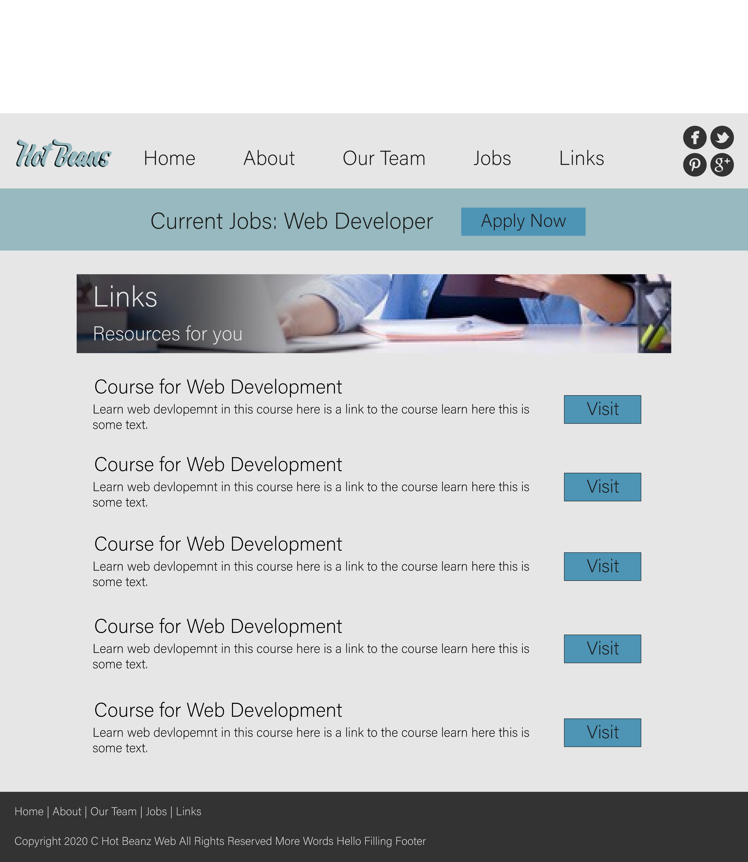

Easier for browser developers to do error handling because HTML 4 error handling was not written down anywhere so they had to test it to see how it worked. HTML 5 fixed this and codified it.

HTML 5 is better for web applications as it supports video and canvases which were previously only done with JavaScript hacks.

There are new elements in HTML 5 such as article, header, and section. These help make the page more readable so it’s not just all divs.

HTML 5 can support whole games such as unity games or converted flash games which makes it good for games. It uses the canvas element to display the graphics. It can also use WebGL to display 3d objects.

HTML 5 is better optimised for mobile devices so it can run on low power devices well.

HTML 5 has local storage abilities so cookies are no longer needed as the local storage will store web data on the user’s computer.

HTML 5 has vector graphics support so it can display svg data in a svg element.